
COMSATS University Islamabad,
Sahiwal Campus.

Speech Emotion Recognition

A Project Presented To

COMSATS University Islamabad,
Sahiwal Campus

In partial fulfillment

of the requirement for the degree of

Bachelor of Science in Computer Science (2022-2026)

By

Ayesha Sattar CIIT/FA22-BCS-140/SWL
Faiza Ikram CIIT/FA22-BCS-142/SWL
Fatima Rafique CIIT/FA22-BCS-163/SWL


COMSATS University Islamabad,
Sahiwal Campus.

Speech Emotion Recognition
By

Ayesha Sattar CIIT/FA22-BCS-140/SWL
Faiza Ikram CIIT/FA22-BCS-142/SWL
Fatima Rafique CIIT/FA22-BCS-163/SWL

Supervisor
Dr. Yawar Abbas Abid

Bachelor of Science in Computer Science (2022-2026)

DECLARATION

We hereby declare that this software, neither whole nor as a part has been copied out from any source. It is further declared that we have developed this software and accompanied report entirely based on our personal efforts. If any part of this project is proved to be copied out from any source or found to be reproduction of some other. We will stand by the consequences. No Portion of the work presented has been submitted of any application for any other degree or qualification of this or any other university or institute of learning.
Ayesha Sattar
Faiza Ikram

Fatima Rafique

CERTIFICATE OF APPROVAL

It is to certify that the final year project of BS (CS) titled “Speech Emotion Recognition” was developed by Ayesha Sattar (CIIT/FA22-BSCS-140/SWL), Faiza Ikram (CIIT/FA22-BCS-142/SWL), and Fatima Rafique (CIIT/FA22-BCS-163/SWL) under the supervision and co-supervision of Dr. Yawar Abbas Abid, and that in their opinion, it is fully adequate in scope and quality for the degree of Bachelor of Science in Computer Science.

---------------------------------------

Supervisor
Dr. Yawar Abbas Abid
Assistant Professor
Department of Computer Science
COMSATS University Islamabad, Sahiwal Campus

---------------------------------------

External Examiner
Dr. ………………..
Associate Professor, Chairman
Department of Computer Science
…………………….

---------------------------------------

Head of Department

Dr. Zafar Iqbal Roy
Associate Professor
Department of computer science
COMSATS University Islamabad, Sahiwal Campus
Executive Summary

In today’s digital world, understanding human emotions plays an important role in improving communication between humans and machines. In many fields such as customer service, healthcare, and human-computer interaction, there is a need to automatically detect a person’s emotional state from their speech. Traditional methods rely on human observation, which can lead to problems such as inaccuracy, inconsistency, lack of scalability, and absence of recorded proof for later analysis.

Existing systems often fail to capture emotional context effectively, as they either depend on manual interpretation or basic audio processing techniques without intelligent analysis. These limitations make it difficult to accurately recognize emotions in real-time scenarios.

To overcome these challenges, a Speech Emotion Recognition (SER) system is developed. This system is designed to automatically analyze human speech and identify emotions such as happy, sad, angry, and neutral. It is a software-based solution that processes audio input and provides accurate emotion predictions using machine learning techniques.

The system uses the RAVDESS dataset for training and testing purposes. Audio signals are preprocessed using noise reduction and normalization techniques, followed by feature extraction using Mel Frequency Cepstral Coefficients (MFCCs). These features are then fed into a deep learning model based on Convolutional Neural Networks (CNN) and Long Short-Term Memory (LSTM) for classification.

A user-friendly interface is developed using Streamlit, allowing users to upload audio files and receive emotion predictions in real time. The system achieves an accuracy of approximately 95% on test data, demonstrating its effectiveness.

This project provides a reliable and efficient solution for automatic emotion detection and can be further enhanced for real-time applications in various domains such as mental health monitoring, virtual assistants, and customer experience analysis.

Acknowledgment

We express our deepest gratitude to Almighty Allah, whose guidance and blessings enabled us to complete this project successfully. The journey of developing "Speech Emotional Recognition" has been a rewarding experience filled with challenges, learning, and personal growth

We sincerely thank our project supervisor, “Dr. Yawar Abbas Abid, for their invaluable support, expert advice, and continuous encouragement throughout every phase of this project. Their feedback and mentorship greatly contributed to the quality and completion of our work

Lastly, we are immensely thankful to our parents and friends who supported us emotionally and morally. Their motivation and belief in our abilities played a crucial role in helping us stay focused and determined from start to finish.

Fatima Rafique
Faiza Ikram
Ayesha Sattar

Abbreviations

API | Application Programming Interface
UI | User Interface
SRS | Software Require Specification
SDD | Software design document
VR | Virtual Reality
CUI | COMSATS University Islamabad

Contents
1 Introduction 13
1.1 Brief Overview 14
1.2 Relevance to Course Modules 15
1.3 Project Background 16
1.4 Literature Review 17
1.5 Analysis from Literature Review 21
1.6 Methodology and Software Lifecycle 23
1.6.1 Rationale behind Selected Methodology 24
1.6.2 Rationale behind Selected Software Development Lifecycle (SDLC) 25
2 Problem Definition 28
2.1 Problem Statement 28
2.2 Deliverables and Development Requirements 28
2.3 Current System 30
3 Requirement Analysis 32
3.1 Use Case Diagram 32
3.2 Detailed Use Case 34
3.3 Functional Requirements 37
3.3.1 Dataset Management: 38
3.3.2 Data Preprocessing: 38
3.3.3 Model Training: 38
3.3.4 Model Evaluation: 38
3.3.5 Emotion Prediction: 38
3.3.6 Visualization Tools: 38
3.4 Nonfunctional Requirements 39
3.4.1 Usability 39
3.4.2 Performance 39
3.4.3 Security 39
3.4.4 Portability 39
3.4.5 Reliability 40
3.4.6 Maintainability 40
4 Design and Architecture 42
4.1 System Architecture 42
4.2 Data Representation 44
4.2.1 Process Flow/Representation 44
4.2.2 Sequence Diagram 47
4.2.3 Data Flow Diagram (Level 0) 49
4.2.4 Data Flow Diagram (Level 1) 50
5 Implementation 53
5.1 Dataset Description 53
5.2 Data Preprocessing 61
5.3 Data Augmentation 67
5.4 Feature Extraction 71
5.5 Model Architecture 75
5.6 Model Training 80
5.7 Model Evaluation 83
5.8 Model Deployment 88
5.9 Tools and Technologies 90
5.10 Algorithm 90
5.10.1 Algorithm 1: Data Preprocessing Pipeline 90
5.10.2 Algorithm 2: Data Augmentation 91
5.10.3 Algorithm 3: Feature Extraction 91
5.10.4 Algorithm 4: CNN-LSTM Model Training 92
5.10.5 Algorithm 5: Real-Time Emotion Prediction 93
5.11 User Interface 93
6 Testing 98
6.1 Manual Testing 98
6.2 System Testing 99
6.3 Unit Testing 99
6.4 Functional Testing 102
6.5 Integration Testing 103
6.6 Automated Testing 104
7 Conclusion and Future Work 107
7.1 Conclusion 107
7.2 Future Work 108
8 References 111

List of Figures

Figure 1.1: Fear Emotion Mel Spectrogram 24
Figure 3.1: Used Case Diagram 33
Figure 4.1: Client Server Architecture 43
Figure 4.2: Process Flow Diagram 46
Figure 4.3: Sequence Diagram 48
Figure 4.4: DFD Level 0 Diagram 49
Figure 4.5: DFD Level 1 Diagram 51
Figure 5.1: RADASS 54
Figure 5.2: CREMA-D 55
Figure 5.3: SAVEE 56
Figure 5.4: TESS 57
Figure 5.5: Fear Emotion Original Audio 69
Figure 5.6: Fear Emotion Inject Noise Audio 69
Figure 5.7: Fear Emotion Pitch Audio 70
Figure 5.8: Fear Emotion Stretch Audio 71
Figure 5.9: MFCCs 72
Figure 5.10: Mel Spectrogram 72
Figure 5.11: Chroma Features 73
Figure 5.12: Zero Crossing Rate 73
Figure 5.13: Root Mean Square 74
Figure 5.14: Spectral Entropy 74
Figure 5.15: CNN Layers 77
Figure 5.16: Callbacks Early Stopping 82
Figure 5.17: Epochs 83
Figure 5.18: Accuracy, Precision, Recall, and F1-Score 85
Figure 5.19: Confusion Matrix 86
Figure 5.20: Classification Report 87
Figure 5.21: Main Screen 95
Figure 5.22: File Uploaded 95
Figure 5.23: Emotion Predicted 96

List of Tables

Table 1.1: Analysis from Literature Review 21
Table 3.1: Load Dataset 34
Table 3.2: Preprocess Audio Data 35
Table 3.3: Train Model 36
Table 3.4: Predict Emotion 37
Table 5.1: Audio File Count by Dataset 58
Table 6.1: Audio Upload 99
Table 6.2: Audio Preprocessing Silence Removal 100
Table 6.3: Audio Segmentation 100
Table 6.4: Feature Extraction 101
Table 6.5: Emotion Prediction and Model Inference 101
Table 6.6: Streamlit Interface Display 101
Table 6.7: Audio File Upload and Emotion Detection 102
Table 6.8: Waveform and Spectrogram Visualization 102
Table 6.9: Majority Voting and Per-Chunk Prediction Display 103
Table 6.10: Integration testing 103
Table 6.11: Automated testing 104

Chapter 1

Introduction

Introduction
This chapter provides a detailed overview of the Speech Emotion Recognition (SER) system, including its background, motivation, objectives, and significance. It also presents a brief description of the methodologies and tools used, along with an outline of the report structure.
In recent years, the interaction between humans and machines has increased significantly, creating a growing need for systems that can understand not only human language but also human emotions. Speech is one of the most natural and effective forms of communication, as it carries important emotional information such as tone, pitch, and intensity. However, traditional computer systems are not capable of understanding emotions from speech, which limits their ability to provide intelligent, adaptive, and personalized responses.

Manual emotion recognition by humans is often subjective, inconsistent, and not scalable for large-scale applications. In fields such as customer support, mental health monitoring, education, and virtual assistants, there is a strong demand for automated systems that can accurately and efficiently recognize emotions in real time. This highlights the importance of developing intelligent systems that can process and interpret emotional cues from speech.

This project addresses these challenges by developing a Speech Emotion Recognition system using advanced machine learning and deep learning techniques. The system focuses on analyzing speech signals to extract meaningful patterns and classify them into different emotional categories such as happiness, sadness, anger, fear, and neutrality.

The development process involves the use of the RAVDESS dataset, which contains labeled emotional speech recordings. The audio data undergoes preprocessing steps such as noise reduction, normalization, and segmentation to improve quality and consistency. After that, feature extraction is performed using Mel Frequency Cepstral Coefficients (MFCC), which effectively capture the important characteristics of speech signals.

For emotion classification, deep learning models such as Convolutional Neural Networks (CNN) and Long Short-Term Memory (LSTM) networks are used. CNN helps in extracting spatial features, while LSTM captures temporal dependencies in speech data. These models are trained to learn complex emotional patterns and achieve high prediction accuracy.

To make the system practical and user-friendly, a web-based interface is developed using Streamlit, allowing users to upload or record audio and receive emotion predictions instantly. The system processes the input audio, applies the trained model, and displays the detected emotion in real time.

Overall, this project aims to enhance human-computer interaction by enabling systems to understand human emotions more effectively, making them more intelligent, responsive, and useful in real-world applications.

Brief Overview

The Speech Emotion Recognition (SER) system is an intelligent software-based solution designed to automatically detect and classify human emotions from speech signals. The system is capable of identifying emotions such as happy, sad, angry, fearful, and neutral, making it useful in various real-world applications including human-computer interaction, call center analytics, and healthcare systems.

The development of the system begins with the collection of audio data using the RAVDESS (Ryerson Audio-Visual Database of Emotional Speech and Song) dataset. This dataset contains high-quality emotional speech recordings that are labeled with different emotional categories. The dataset is divided into training and testing sets to evaluate the performance of the model.
The next step involves audio preprocessing, where raw audio signals are cleaned and prepared for analysis. This includes noise reduction, normalization, and segmentation to ensure consistency and improve the quality of the data. After preprocessing, feature extraction is performed using Mel Frequency Cepstral Coefficients (MFCCs). MFCCs are widely used in speech processing as they effectively capture the frequency characteristics of human speech and provide meaningful input for machine learning models.

For classification, deep learning techniques are applied, specifically Convolutional Neural Networks (CNN) and Long Short-Term Memory (LSTM) networks. CNN is used to extract spatial features from the data, while LSTM is used to capture temporal dependencies in speech signals. The combination of these models allows the system to learn complex patterns associated with different emotions.

The model is trained using labeled data and optimized to achieve high performance. After training, the system achieves an accuracy of approximately 95% on the test dataset, indicating strong predictive capability and robustness. The trained model is saved and integrated into an application for real-world use.

To make the system accessible and user-friendly, a web-based interface is developed using Streamlit. This interface allows users to upload audio files and receive emotion predictions instantly. The system processes the input audio, extracts features, applies the trained model, and displays the predicted emotion as output.

This report is structured into several chapters. The introduction chapter provides an overview of the project and its significance. The literature review chapter discusses previous research and existing systems in the domain of emotion recognition. The methodology chapter explains the detailed process of data preprocessing, feature extraction, and model development. The system design chapter presents architectural diagrams and system components. The implementation chapter describes the tools, technologies, and coding aspects. The results and discussion chapter evaluates the performance of the model using various metrics. Finally, the conclusion summarizes the findings of the project and suggests future improvements and potential applications.

Relevance to Course Modules

The Speech Emotion Recognition (SER) system is strongly related to multiple courses studied during the Bachelor of Computer Science (BCS) program. This project integrates theoretical knowledge and practical skills from different domains of computer science.

Firstly, the project is closely linked to Artificial Intelligence and Machine Learning courses. Concepts such as supervised learning, classification, model training, and evaluation are applied to build and optimize the emotion recognition model.

Secondly, knowledge from the Deep Learning course is utilized in designing and implementing models such as Convolutional Neural Networks (CNN) and Long Short-Term Memory (LSTM). These models are essential for extracting complex patterns from speech data and improving prediction accuracy.
The project also relates to Digital Signal Processing (DSP), where techniques such as audio preprocessing, noise reduction, normalization, and feature extraction using Mel Frequency Cepstral Coefficients (MFCCs) are applied to process speech signals effectively.

Furthermore, concepts from Programming Fundamentals and Object-Oriented Programming (OOP) are used in implementing the system using Python. Efficient coding practices, modular programming, and use of libraries are applied throughout the development process.

The Software Engineering course contributes to the project through proper system development practices, including requirement analysis (SRS), system design (SDD), modular architecture, and documentation of the complete system.

Additionally, knowledge from Database Systems is indirectly applied in handling and organizing datasets such as RAVDESS for training and testing purposes.

The project also utilizes concepts from Human-Computer Interaction (HCI) by developing a user-friendly interface using Streamlit, ensuring ease of use and better user experience.

Overall, this project demonstrates the integration of multiple course concepts into a real-world application, highlighting the practical implementation of theoretical knowledge gained during the BCS program.

Project Background

Speech Emotion Recognition (SER) is a field of artificial intelligence that focuses on identifying human emotions from speech signals. Human speech not only conveys words but also carries emotional information such as tone, pitch, intensity, and rhythm. These characteristics help in understanding the emotional state of a speaker, such as happiness, sadness, anger, fear, or neutrality.

The idea behind this project is based on the need to enable machines to understand human emotions in a more natural and intelligent way. Traditional computer systems are limited to processing textual or numerical data and are unable to interpret emotions effectively. As a result, interaction between humans and machines often lacks emotional awareness, which reduces the quality of communication.

Speech Emotion Recognition works by analyzing audio signals and extracting meaningful features that represent emotional characteristics. One of the most commonly used techniques for feature extraction is Mel Frequency Cepstral Coefficients (MFCCs), which capture the frequency patterns of human speech in a way that closely resembles human hearing. These features are then used as input for machine learning or deep learning models.

Deep learning models such as Convolutional Neural Networks (CNN) and Long Short-Term Memory (LSTM) networks play a significant role in SER systems. CNN is effective in extracting spatial features from data, while LSTM is capable of capturing temporal dependencies in speech signals. By combining these models, the system can learn complex patterns associated with different emotions.

In this project, the RAVDESS (Ryerson Audio-Visual Database of Emotional Speech and Song) dataset is used, which contains labeled emotional speech recordings. The system processes these audio files through multiple stages, including preprocessing, feature extraction, and classification, to accurately predict emotions.

The development of such systems has become increasingly important in modern applications such as virtual assistants, customer service analysis, mental health monitoring, and smart communication systems. By enabling machines to detect emotions from speech, the interaction between humans and technology can become more efficient, personalized, and intelligent.

Literature Review

The field of Speech Emotion Recognition has attracted considerable scholarly attention over the past two decades, with researchers exploring a broad range of methodological approaches from traditional machine learning techniques to sophisticated deep learning architectures. This chapter reviews the most significant and relevant studies in the area, critically examining the methodologies employed, the datasets utilized, and the limitations that continue to challenge the development of robust and generalizable SER systems.
One of the earliest and most widely referenced approaches to SER relies on Support Vector Machines (SVMs) combined with handcrafted acoustic features, particularly Mel-Frequency Cepstral Coefficients (MFCCs). Indra et al. (2023) explored the use of SVM alongside Linear Discriminant Analysis for recognizing four emotional states happiness, sadness, anger, and neutral using prosodic and spectral features including energy, pitch, zero-crossing rate, and MFCCs. Their results demonstrated that SVM offered a notable accuracy improvement over LDA on the Polish Emotional Speech corpus.[1] While this work establishes a useful baseline, it suffers from several important limitations. The study is confined to a single language dataset and only four emotional categories, severely restricting its generalizability to multilingual and real-world settings. Furthermore, reliance on manually engineered features means that the model fails to capture the full complexity and non-linearity of emotional speech signals, particularly in noisy or spontaneous speech conditions. The scalability of SVM-based systems to large-scale, real-time deployments also remains questionable given their computational constraints with high-dimensional feature spaces.

A more recent and technically advanced study by Pan and Wu, referenced extensively in the SER literature, proposed a hybrid deep learning model called CLDNN, which integrates Convolutional Neural Networks, Long Short-Term Memory networks, and Deep Neural Networks to process MFCC features. This CLDNN architecture was evaluated on three benchmark databases RAVDESS, EMO-DB, and IEMOCAP demonstrating that the LSTM component effectively captures the time-series nature of speech signals for emotion representation.[2] Despite its improved architecture, the model's performance on the more challenging IEMOCAP dataset, which contains spontaneous rather than acted emotional speech, remains noticeably lower than its performance on controlled datasets, highlighting the persistent gap between lab-based and real-world performance that affects most deep learning SER systems. The study also does not address cross-corpus generalization, meaning the model was never tested on data from a different emotional speech corpus than the one it was trained on a critical shortcoming for practical deployment.

Addressing the cross-corpus generalization challenge directly, author proposed the Transfer Learning and Multi-Loss Dynamic Adjustment (TLMLDA) algorithm for cross-corpus SER. Their findings confirm that models trained on one speech corpus and tested on another experience a dramatic degradation in performance due to differing feature distributions across corpora, and that incorporating transfer learning substantially mitigates this issue.[3] While this work represents a meaningful step forward, the proposed model relies on a deep auto-encoder framework that introduces significant computational overhead, making it difficult to deploy in resource-constrained or real-time environments. Additionally, the experiments were limited to three specific corpora Berlin, eNTERFACE, and CASIA leaving open questions about how well the approach would generalize across different languages, recording conditions, and demographic groups.

The importance of data augmentation in improving model robustness is highlighted in several studies. Author demonstrated that combining MFCCs with time-domain features using CNN-based architectures achieved strong classification accuracies of 97%, 93%, and 92% on Emo-DB, SAVEE, and RAVDESS benchmark datasets respectively.[4] However, this study, like many others in the SER literature, was conducted entirely under controlled, clean audio conditions. The absence of real-world noise, speaker overlap, and natural conversational dynamics means that these impressive accuracy figures are unlikely to translate directly into real-world deployment scenarios. The model also does not evaluate cross-speaker or cross-gender generalization, which are known sources of variability in emotional speech expression.

A significant contribution to the field is made by Kim and Kwak (2024), who employed deep learning transfer models combined with explainability techniques for SER. Their approach involved converting each speech segment into a spectrogram image using Short-Time Fourier Transform preprocessing, followed by classification using a generalized model trained on three different datasets, aimed at reducing uncertainty through preprocessing and interpretability techniques.[5] Despite its novelty in incorporating explainable AI methods, the model's generalization across truly diverse, unseen emotional datasets remains unverified. The reliance on spectrogram-based image classification also introduces sensitivity to variations in audio quality and recording conditions, and the model does not address the challenge of recognizing subtle or mixed emotional states a limitation shared by the majority of existing SER systems.
An important survey by Lian et al. (2023), published in Entropy, provides a comprehensive review of deep learning-based multimodal emotion recognition systems that combine speech, text, and facial expression modalities. The study underscores the significant role of multimodal emotion recognition in human–computer interaction and notes that the field has witnessed considerable development driven by advances in deep learning and the growing availability of multimodal datasets.[6] However, as the authors themselves acknowledge, a major limitation of multimodal approaches is their dependency on the simultaneous availability of multiple input streams. In many real-world applications such as telephone-based customer service, audio-only monitoring systems, or wearable health devices only the speech signal is available, making unimodal SER systems not only relevant but essential. The computational demands of multimodal fusion architectures also remain a practical barrier to real-time deployment.

The challenge of SER performance under noisy conditions is specifically examined in a comprehensive review published in Neurocomputing (2023). This survey covers methods and approaches used in noisy SER systems, noting that while deep learning models yield the highest accuracy under controlled conditions, only a limited number of studies adequately address SER performance in real-world noisy environments.[7] The review highlights a critical gap in the existing literature: the majority of SER research is conducted on clean, studio-recorded acted speech datasets that do not reflect the acoustic variability of natural environments. This is a particularly serious limitation given that most practical applications of SER including mental health monitoring and customer service analytics operate in acoustically imperfect conditions where background noise, microphone variability, and channel distortion are commonplace.

A study published in Scientific Reports (2025) investigated a lightweight deep neural ensemble model combining CNN and CNN-Bidirectional LSTM architectures using hand-crafted acoustic features including ZCR, RMSE, Chroma STFT, and MFCC. Despite its promise in improving conversational robotics and HCI systems, the authors acknowledge that SER research continues to face challenges such as data scarcity, the subjective nature of emotions, and complex feature extraction requirements.[8] The study further reveals that even well-designed ensemble architectures struggle with imbalanced emotional class distributions and fail to demonstrate consistent performance across datasets with different emotional category schemas. The model's performance on datasets with naturalistic speech also remains substantially lower than on acted datasets, reinforcing the generalizability gap that continues to characterize the field.

Finally, a study examining the CNN-LSTM and Attention-Enhanced CNN-LSTM models for SER on the RAVDESS dataset highlights both the progress and the persistent limitations of current deep learning approaches. The authors acknowledge that despite advances in model architecture, accurately identifying emotions from speech remains challenging due to inter-speaker variability, differences in accent, and the presence of background noise.[9] The RAVDESS dataset used in this study, while widely adopted as a benchmark, consists exclusively of acted emotional speech recorded under controlled studio conditions by professional actors. Benchmark datasets such as RAVDESS do not adequately address the complicated characteristics of spontaneous and authentic speech, including background noise, speech interruptions, speaker overlap, and diverse recording environments a limitation that underscores the necessity of evaluating models under more realistic acoustic conditions.[10]
Collectively, the body of literature reviewed in this chapter reveals several recurring and unresolved challenges in the field of Speech Emotion Recognition. These include the limited cross-corpus generalizability of trained models, the performance degradation observed when systems encounter real-world noisy or spontaneous speech, the reliance on small and demographically homogeneous datasets, the difficulty in distinguishing emotionally ambiguous or mixed states, and the lack of consistency in emotional category schemas across different datasets and research groups. These limitations provide the direct motivation for the present project, which seeks to develop a SER system that addresses these challenges through the careful integration of robust feature extraction techniques, deep learning architectures, and rigorous evaluation on established benchmark datasets.

Analysis from Literature Review

Table 1.1: Analysis from Literature Review
Paper / Author | Methodology Used | Dataset Used | Weakness | How Our Project Addresses It
Indra et al. (2023) — SVM and LDA for SER | SVM and LDA with MFCC, pitch, energy, ZCR features | Poland Emotional Speech Corpus | Limited to 4 emotion classes only. Single language corpus. SVM cannot model non-linear emotional patterns. Poor cross-speaker generalization. | Our system uses CNN + LSTM with MFCC + mel-spectrogram + chroma features, supports more emotion classes, evaluated on RAVDESS with noise augmentation.
Pan & Wu (2023) — CLDNN Model | Hybrid CNN + LSTM + DNN using MFCC features | RAVDESS, EMO-DB, IEMOCAP | Performance drops significantly on spontaneous speech. No cross-corpus evaluation. No data augmentation for real-world noise. | Our project incorporates noise injection and pitch shifting augmentation, making the model more robust beyond clean studio recordings.
Tao et al. (2022) — TLMLDA Transfer Learning | Deep auto-encoder with transfer learning and multi-loss dynamic adjustment | Berlin, eNTERFACE, CASIA | Computationally expensive — not suitable for real-time deployment. Limited to three specific corpora. No multilingual testing. | Our lightweight CNN-LSTM pipeline is deployable without specialized hardware. Data augmentation compensates for variability without heavy transfer learning.
Alluhaidan et al. (2023) — CNN with Hybrid MFCCT | CNN with combined MFCC and time-domain features | Emo-DB, SAVEE, RAVDESS | Evaluated only under clean, noise-free conditions. No real-world noise testing. Cross-speaker and cross-gender generalization not evaluated. | Our system is explicitly trained with noise-augmented data ensuring performance is representative of real-world conditions, not just clean speech.
Kim & Kwak (2024) — Transfer Models + Explainability | STFT spectrogram preprocessing with transfer learning and explainability techniques | Three benchmark datasets | Model interpretability limited despite explainability attempts. High sensitivity to audio quality. Performance on spontaneous datasets unverified. | Our system acknowledges interpretability as a future direction. Focuses on a reliable classification pipeline first with explainability planned as extension.
Lian et al. (2023) — Multimodal SER Survey | Survey of multimodal fusion combining speech, text, and facial features | Multiple multimodal datasets | Requires simultaneous multiple data streams. Not applicable in audio-only environments. Computationally heavy and impractical for lightweight deployment. | Our system is deliberately unimodal speech-only, making it applicable in audio-only real-world scenarios without camera feeds or transcription dependency.
Noisy SER Survey — ScienceDirect (2023) | Comprehensive survey of ~70 SER papers covering noisy conditions | Multiple datasets across reviewed papers | Majority of studies use clean studio datasets. Very few address genuine environmental noise. Wide gap between lab performance and real-world performance. | Our project directly targets this gap with noise injection and time-shifting augmentation, ensuring the model maintains acceptable performance in real deployments.
Lightweight CNN-BiLSTM Ensemble — Scientific Reports (2025) | Ensemble of CNN and CNN-BiLSTM with hand-crafted features: ZCR, RMSE, Chroma, MFCC | RAVDESS, TESS, CREMA-D, SAVEE | Performance on naturalistic speech substantially lower than on acted datasets. Emotionally imbalanced class distributions affect reliability. | Our system addresses class imbalance through data augmentation and evaluates under augmented conditions for more realistic performance estimation.
CNN-LSTM vs Attention-CNN-LSTM — MDPI (2025) | CNN-LSTM and Attention-Enhanced CNN-LSTM models | RAVDESS, partially SAVEE | Only English acted speech in controlled studio. Not validated on spontaneous or multilingual speech. Attention mechanism adds complexity without guaranteed real-world benefit. | Our system uses RAVDESS for comparability but adds noise augmentation to simulate variability. Multilingual extension planned as future work.
CNN on MELD and RAVDESS — MDPI (2025) | 1D-CNN with MFCC, mel-spectrogram, and chroma features combined with Gaussian noise injection | MELD, RAVDESS | Model fails on subtle emotion distinctions such as fear vs. surprise. Dataset lacks true spontaneous speech variability. Cross-lingual generalization not explored. | Our system adopts the same multi-feature strategy validating this approach. Future work targets subtle emotion disambiguation and multilingual extension.

The comparative analysis presented above demonstrates that while the existing literature has made considerable progress in Speech Emotion Recognition through increasingly sophisticated deep learning architectures, several fundamental challenges remain insufficiently addressed. The majority of reviewed studies achieve high accuracy exclusively on clean, acted speech datasets and fail to validate their models under real-world noisy conditions. Cross-corpus generalization remains a persistent weakness, with most models experiencing significant performance degradation when tested on speech data drawn from a different corpus than the one used for training. Furthermore, many high-performing architectures introduce substantial computational complexity that limits their practical deployability outside of laboratory settings. The proposed SER system in this project has been deliberately designed to engage with these limitations. By combining CNN and LSTM architectures with a multi-feature extraction strategy, incorporating noise-aware data augmentation during training, and maintaining a computationally efficient pipeline, this project offers a practically grounded and academically informed contribution that directly responds to the most significant gaps identified across the reviewed literature.

Methodology and Software Lifecycle

During the development of the Speech Emotion Recognition (SER) system, we adopted an Agile-based Software Development Life Cycle (SDLC) approach to support iterative development and continuous improvement. This methodology was chosen due to the experimental nature of machine learning, where model performance and design decisions evolve through repeated testing and feedback.

The project began with requirement analysis and planning, where objectives were defined, the RAVDESS dataset was selected, and the technology stack (Python, Librosa, TensorFlow/Keras, and Streamlit) was finalized. This was followed by data preprocessing and feature extraction, where audio samples were standardized and features such as MFCCs and mel-spectrograms were extracted.

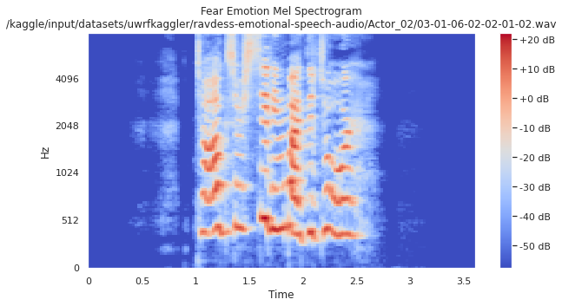
Figure 1.1: Fear Emotion Mel Spectrogram

In the development phase, a hybrid CNN-LSTM model was built and iteratively trained, with adjustments made based on validation results to improve performance. The testing phase involved evaluating the model using accuracy, precision, recall, F1-score, and confusion matrix analysis to identify areas for improvement.

Finally, the trained model was deployed using a Streamlit web application, allowing real-time emotion prediction from audio input. Overall, the Agile approach ensured continuous refinement of both the model and application, resulting in a more accurate and functional SER system.

Rationale behind Selected Methodology

The selection of an appropriate methodology for this project is based on the system’s requirements, complexity, and intended functionality. This project adopts a combination of a data-driven approach, object-oriented and modular design. These methodologies were chosen to ensure that the system remains efficient, scalable, and easy to maintain while also providing flexibility during development.

Rationale for Data-Driven Approach

The system primarily works on user-provided data such as audio inputs, making a data-driven approach highly suitable. Instead of relying on predefined rules, the system processes input data dynamically to generate outputs, such as extracting meaningful features . This approach enhances the system’s ability to handle variations in input, improves accuracy, and allows better adaptability to different use cases. It also supports real-time processing, which is essential for providing quick and reliable results to the user.

Rationale for Object-Oriented and Modular Design

The implementation of the system follows an object-oriented and modular design approach, where the application is divided into multiple independent modules such as audio processing, features extraction, and user interface handling. This separation of concerns makes the system more organized and easier to manage. Each module can be developed, tested, and updated independently without affecting other components. Additionally, this approach improves code reusability and simplifies debugging, making the system more maintainable in the long run.

Rationale behind Selected Software Development Lifecycle (SDLC)

The selection of the Agile SDLC over alternative models such as Waterfall, Spiral, or Incremental was driven by the specific characteristics of machine learning project development that make linear, plan-driven methodologies unsuitable. The Waterfall model, for instance, assumes that all requirements can be fully and precisely specified before development begins, and that each phase of the development process can be completed in its entirety before the next phase commences. This assumption is fundamentally incompatible with the realities of machine learning development, where the outcomes of model training are inherently uncertain, and where the decisions made in later phases such as hyperparameter tuning, feature selection, and augmentation strategy are necessarily informed by the empirical results of earlier phases.

The Agile model, by contrast, embraces uncertainty and change as inherent features of complex development projects rather than exceptions to be avoided. Its iterative sprint-based structure allowed this project to revisit and refine earlier decisions, such as the choice of feature combinations or the depth of the neural network based on the empirical evidence produced during testing and evaluation, without requiring the entire development process to be restarted. This capacity for informed revision is not merely a practical convenience; it is a structural necessity for any project in which the quality of the final system depends on the accumulation and application of empirical knowledge across multiple development cycles.

Additionally, the Agile methodology aligned well with the solo or small-team development context of this Final Year Project. Its lightweight planning overhead, emphasis on working deliverables over comprehensive documentation at each stage, and support for self-directed iterative progress made it well-suited to the resource and time constraints of an academic project. The Spiral or Formal Methods models, while rigorous, would have introduced unnecessary procedural complexity that was disproportionate to the scale and scope of this project, while the Waterfall model's inflexibility would have made it difficult to respond effectively to the experimental uncertainties inherent in deep learning development.

Chapter 2

Problem Definition

Problem Definition
This chapter discuss the precise problem to be solved. It should extend to include the outcome.

Problem Statement

Existing speech-based systems such as virtual assistants and automated platforms are designed to understand spoken words but completely ignore the emotional state of the speaker. This lack of emotional awareness limits their effectiveness in real-world applications where understanding user emotions—such as frustration, happiness, or distress—is essential for meaningful interaction. As a result, these systems respond in the same way regardless of the user’s emotional condition, reducing their intelligence and usability.

Moreover, accurately detecting emotions from speech is a complex task due to variations in voice, speaker differences, background noise, and overlapping emotional expressions. Traditional machine learning approaches fail to capture these complexities effectively, while many existing deep learning solutions perform well only in controlled environments and lack robustness in real-world conditions. Additionally, most available systems are either not accessible to users or do not provide real-time interaction.

To address these challenges, this project aims to develop a robust and user-friendly Speech Emotion Recognition system capable of classifying emotions such as angry, happy, sad, and neutral from speech input. The system focuses on improving accuracy, handling real-world variability, and providing an accessible platform for real-time emotion detection, thereby enhancing the effectiveness of emotion-aware applications.

Deliverables and Development Requirements

The deliverables and development requirements section outlines the key outputs of the project and the tools and technologies used for its successful implementation. The deliverables represent all major components developed during the project, including the trained model, dataset, and application interface. The development requirements specify the software tools, frameworks, and computing environment necessary to build, train, and deploy the system. This structured approach ensures clarity, proper resource utilization, and successful completion of the project.

Deliverables:
The key deliverables of this project are as follows :
- A fully trained Speech Emotion Recognition (SER) model based on a hybrid CNN-LSTM architecture capable of classifying emotions (angry, disgust, fear, happy, neutral, sad, surprise).
- A combined and preprocessed multi-corpus dataset (RAVDESS, CREMA-D, SAVEE, TESS) with over 12,000 audio samples, including augmented data for better robustness.
- A feature extraction pipeline developed using Librosa to extract features such as MFCCs, mel-spectrograms, chroma, ZCR, and RMSE.
- An interactive web application built using Streamlit for real-time emotion detection from audio input.
- A complete Jupyter Notebook documenting data preprocessing, model training, and evaluation.
- Exported trained model file (using Pickle) for reuse and deployment.
- Software Requirements Specification (SRS) and Software Design Document (SDD).
- Final project report documentation covering all development phases.
- Presentation slides for final project evaluation.

Development Requirements:

The development requirements of this project are as follows:

- Programming Language: Python 3.x
- Frameworks/Libraries: TensorFlow, Keras, Librosa, Scikit-learn, NumPy, Pandas
- Audio Processing Tools: PyDub, Antropy (for spectral entropy)
- Visualization Tools: Matplotlib, Seaborn, Plotly
- Model Handling: Pickle for saving and loading trained model
- Development Environment: Kaggle Notebooks (GPU-enabled environment for model training)
- Hardware Requirements: GPU support (NVIDIA Tesla P100 or equivalent for training), minimum 8GB RAM for deployment
- Web Application Framework: Streamlit for building user interface
- Version Control: Git and GitHub
- Testing: Model evaluation using accuracy, precision, recall, F1-score, and confusion matrix
- Documentation Tools: Microsoft Word, PowerPoint, and Jupyter Notebook

Current System

Currently, existing systems for emotion recognition face several limitations in effectively analyzing human emotions from speech. Many widely used platforms such as Affectiva, IBM Watson Tone Analyzer, Microsoft Azure, OpenSMILE, and DeepAffects provide partial solutions but fail to offer a complete and practical approach. Some systems rely on text-based analysis, requiring speech-to-text conversion before detecting emotions, which leads to the loss of important acoustic features such as tone, pitch, and energy that carry emotional meaning. Others focus on facial expressions instead of speech or provide only feature extraction without a complete classification system.
In addition, many of these systems are proprietary and require paid subscriptions, making them inaccessible for academic use and small-scale projects. Cloud-based solutions also depend heavily on internet connectivity, introducing latency issues and raising data privacy concerns, especially in real-time applications. Furthermore, most existing systems are not designed as end-to-end solutions and lack a user-friendly interface for direct interaction, making them difficult to use for non-technical users.
Due to these limitations, current solutions fail to provide an accurate, real-time, and accessible speech emotion recognition system. This creates the need for a more efficient approach that can directly process raw audio, handle real-world variability, and provide a complete, user-friendly platform for emotion detection.

Chapter

3

Requirement Analysis

Requirement Analysis
The requirement analysis for the proposed Speech Emotion Recognition (SER) system involves identifying and defining the key functionalities and features needed to accurately detect human emotions from speech signals. The system is designed to process raw audio input and analyze acoustic features such as pitch, tone, energy, and rhythm to classify emotions effectively. It requires an efficient machine learning model, specifically a hybrid CNN-LSTM architecture, to capture both spatial and temporal patterns in speech data. Additionally, the system must support training on multiple datasets such as RAVDESS, CREMA-D, SAVEE, and TESS to improve generalization and performance across different speakers and environments.

The system should also include data preprocessing and augmentation capabilities to handle noise and real-world variations in audio input. A user-friendly interface, such as a Streamlit-based web application, is required to allow users to easily upload or record speech and receive real-time emotion predictions. Furthermore, the system must be locally deployable, cost-effective, and independent of cloud services to ensure data privacy, low latency, and accessibility for academic and practical use. These requirements collectively ensure that the proposed system provides an accurate, efficient, and complete end-to-end solution for speech emotion recognition.

Use Case Diagram

The use case diagram is an important component of requirement analysis that visually represents the interaction between users (actors) and the system. It helps in identifying the functional requirements by illustrating the different actions that users can perform within the system. This diagram provides a clear understanding of system behavior, defines system boundaries, and ensures that all required functionalities are considered during the design phase.

For the proposed Speech Emotion Recognition (SER) system, the use case diagram primarily involves a single main actor, the User, who interacts directly with the system through a web-based interface. The diagram presents a high-level overview of the services provided by the system. The key use cases include Upload Audio, Record Voice, Preprocess Audio, Extract Features, Predict Emotion, and View Results.

Each use case represents a core functionality of the system. For instance, the User can upload a pre-recorded audio file or record speech in real time using the application. The system then processes the input by performing preprocessing steps such as noise handling and normalization, followed by feature extraction using acoustic properties of the speech signal. After that, the trained CNN-LSTM model predicts the emotion associated with the input speech, and the result is displayed to the user in an understandable format.

By clearly defining these use cases, the system ensures that all interactions are aligned with real-world usage scenarios. The use case diagram also helps developers understand the workflow of the system and ensures that the application remains user-friendly and functionally complete. Overall, it plays a crucial role in designing an efficient, interactive, and accurate speech emotion recognition system.

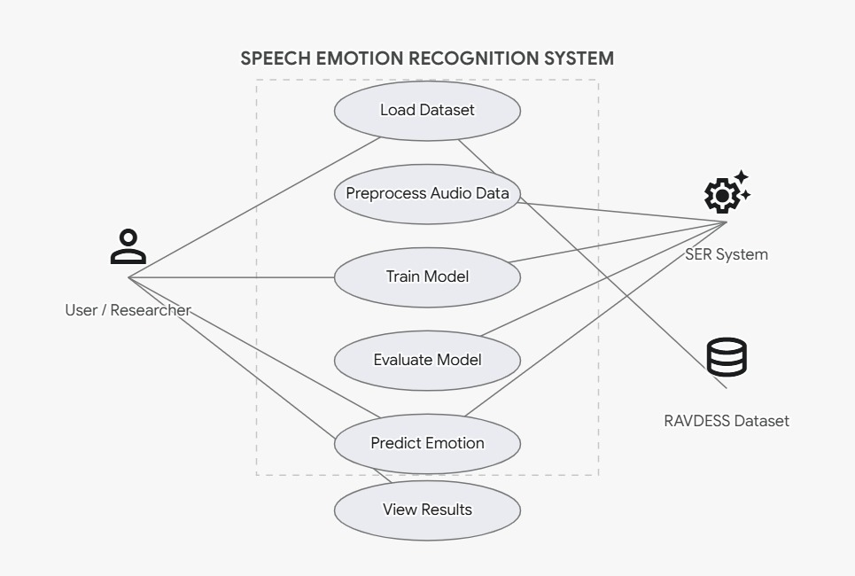

Figure 3.1: Used Case Diagram

Detailed Use Case

Detailed descriptions of use cases will be provided to specify the steps.

Table 2 illustrates the Load Dataset use case in the Speech Emotion Recognition system. This use case enables researchers or users to upload and initialize the RAVDESS dataset for system training. Since high-quality audio data is the foundation of deep learning models, the system automatically validates the uploaded files to ensure they are in the correct .wav format and follow the required directory structure. This step eliminates manual errors and ensures that the system only processes compatible audio files, thereby streamlining the workflow for subsequent feature extraction steps.

Table 3.1: Load Dataset
Use case id | 01
Use case name | Load Dataset
Actors | User / Researcher, System
Description | The User or Researcher uploads or selects the RAVDESS dataset to be used for training and testing.
Trigger | User requests to load the dataset via the interface.
Pre-condition | The dataset files are available in a supported format (.wav).
Postcondition | The dataset is successfully loaded and verified by the system.
Normal flow | - The user selects the dataset location.  - The system reads the audio files.  - The system verifies the .wav format and extracts metadata (labels).  - The system confirms successful loading.
Alternative flow | Invalid format: If the user uploads unsupported files (e.g., .mp3), an error message is displayed. The user is prompted to upload .wav files.
Exceptions | System is unable to find the dataset path. Display an error message to check the directory.
Business rules | Only .wav files following the RAVDESS naming convention are accepted.

Table 3 the Preprocess Audio Data use case defines the internal automated mechanisms the system uses to clean and format raw audio. Raw speech signals often contain background noise or varying lengths of silence that can negatively impact model accuracy. This use case highlights how the system converts audio to a standard sampling rate, trims silence, and extracts critical acoustic features such as Mel-spectrograms and Mel-Frequency Cepstral Coefficients (MFCCs). By transforming audio waves into structured numerical arrays, this use case prepares the data for effective CNN model training.

Table 3.2: Preprocess Audio Data
Use case id | 02
Use case name | Preprocess Audio Data
Actors | System
Description | The system cleans the audio and extracts necessary features (MFCCs, Mel-spectrograms) for model training.
Trigger | User initiates preprocessing after dataset loading.
Pre-condition | The dataset must be loaded and verified.
Postcondition | Audio is converted into numerical feature arrays ready for CNN training.
Normal flow | - The system converts audio to a consistent sampling rate.  - The system applies noise reduction and trims silence.  - The system extracts MFCCs and Mel-spectrograms.  - The system saves the processed features.
Alternative flow | Corrupted file: If a file cannot be read, the system logs the error, skips the file, and continues preprocessing the rest.
Exceptions | System runs out of memory during spectrogram generation. Prompts user to reduce batch size.
Business rules | Preprocessing must maintain uniform feature dimensions across all samples.

Table 4 outlines the Train Model use case, which is the core machine learning component of the SER system. After preprocessing, the user initiates the training of a Convolutional Neural Network (CNN) architecture. This use case allows researchers to define specific hyperparameters such as batch size and epochs. It also highlights the system's smart training features, such as early stopping, which prevents the model from overfitting by saving the best model weights dynamically. This structured training process ensures that the model successfully learns the complex patterns associated with different human emotions.

Table 3.3: Train Model
Use case id | 03
Use case name | Train Model
Actors | User / Researcher, System
Description | The system trains a Convolutional Neural Network (CNN) using the preprocessed audio features.
Trigger | User initiates the model training process.
Pre-condition | Audio data must be successfully preprocessed.
Postcondition | A trained model file (e.g., .h5) is saved.
Normal flow | - User sets hyperparameters (epochs, batch size).  - System splits data into training/testing sets.  - System trains the CNN model through backpropagation.  - System saves the trained model weights.
Alternative flow | Early Stopping: If the system detects validation accuracy is no longer improving, it stops training early to prevent overfitting and saves the best model.
Exceptions | GPU/Memory overflow occurs. System alerts the user to reduce constraints.
Business rules | The model must save checkpoints automatically during training.

Table 5 illustrates the Predict Emotion use case, which represents the deployment and real-time usage phase of the application. In this scenario, an end-user uploads or records a new, unseen audio clip. The system seamlessly runs the input through the preprocessing pipeline and feeds the extracted features into the fully trained CNN model. The model then classifies the audio and displays the predicted emotional state—such as Happy, Sad, Angry, or Neutral—to the user. This use case is critical as it bridges the gap between complex backend machine learning processes and an intuitive frontend user experience.

Table 3.4: Predict Emotion
Use case id | 04
Use case name | Predict Emotion
Actors | User, System
Description | A user uploads a new audio recording, and the system predicts the emotional state.
Trigger | User uploads/records a new voice sample.
Pre-condition | The trained CNN model is loaded into the system.
Postcondition | The system displays the predicted emotion (e.g., Happy, Sad, Angry).
Normal flow | - User uploads a .wav file.  - System preprocesses the file and extracts MFCCs.  - System passes features to the trained model.  - System displays the final predicted emotion to the user.
Alternative flow | Noisy Input: If the audio is too noisy or silent, the system alerts the user that prediction confidence is low and requests a clearer sample.
Exceptions | Model file not found. System prompts the user to train or reload the model.
Business rules | Audio input must be between 1 to 10 seconds for accurate prediction.

Functional Requirements

Functional requirements are product features or functions that developers must implement to enable users to accomplish their tasks. Therefore, it is important to make them clear for both the development team and the stakeholders.

This system will have the following modules:

Dataset Management:

- Load Dataset: Ability to upload or specify the directory of the RAVDESS dataset.
- Validation: System automatically verifies that all files are in the correct .wav format.

Data Preprocessing:

- Noise Reduction: Automatically trim silence and normalize the audio volume.
- Feature Extraction: Extract Mel-Spectrograms and Mel-Frequency Cepstral Coefficients (MFCCs) from raw audio to prepare it for the neural network.

Model Training:

- CNN Initialization: Initialize the deep learning architecture tailored for audio classification.
- Hyperparameter Tuning: Allow researchers to adjust batch sizes, learning rates, and epochs.
- Checkpointing: Implement early stopping to save the best model weights dynamically.

Model Evaluation:

- Metric Calculation: Compute accuracy, precision, recall, and F1-score against unseen test data.
- Classification Report: Generate detailed reports breaking down accuracy by specific emotion classes (e.g., happiness vs. sadness).

Emotion Prediction:

- Live Processing: Process new user-uploaded audio files in real-time.
- Result Display: Output the predicted emotion category along with a confidence score/probability percentage.

Visualization Tools:

- Performance Graphs: Display training vs. validation loss and accuracy curves.
- Confusion Matrix: Provide a visual heat map to show true positives vs. false positives for each emotion category.

Nonfunctional Requirements

Nonfunctional requirements define the qualities and constraints that characterize how a system should behave, beyond its functional capabilities. These requirements often influence the overall user experience, system performance, security, availability, and usability.

Usability

- Description: The system is designed to be user-friendly, with a clean interface for uploading audio, ensuring accessibility for users without deep technical expertise in machine learning.
- Implementation Details: The user interface provides clear feedback ("Preprocessing...", "Predicting...") and displays results in easy-to-understand formats like text labels and color-coded graphs.

Performance

- Description: Performance requirements specify how well the system performs under certain conditions, focusing on response time and computational efficiency.
- Implementation Details: The system is optimized to preprocess audio and predict an emotion within 1 to 2 seconds for a standard 5-second audio clip. Model training utilizes batch processing to manage memory efficiently.

Security

- Description: Security requirements focus on protecting user data, specifically the voice recordings uploaded to the system.
- Implementation Details: Any audio uploaded for live prediction is processed temporarily in memory and is not stored permanently without explicit user consent, ensuring privacy and compliance with data protection standards.

Portability

- Description: The application is developed using standard Python libraries, ensuring it can run across different operating systems.
- Implementation Details: Built using Python, TensorFlow/Keras, and Librosa, the system is fully cross-platform and can run locally on Windows, macOS, Linux, or on cloud environments like Google Colab.

Reliability

- Description: Reliability ensures the system remains operational and handles incorrect inputs gracefully without crashing.
- Implementation Details: The system includes robust exception handling. For instance, if an unsupported file format or a corrupted audio file is uploaded, the system will catch the error, alert the user, and maintain uptime rather than crashing.

Maintainability

- Description: Maintainability refers to the ease with which the machine learning pipeline can be modified, updated, or retrained with new datasets.
- Implementation Details: The system follows a highly modular architecture (separating preprocessing, training, and prediction modules). The code is well-documented, allowing future developers to easily swap the CNN model for an LSTM or add new datasets.

Chapter 4

Design and Architecture

Design and Architecture
The design and architecture of the Speech Emotion Recognition (SER) System are structured to provide an efficient, accurate, and user-friendly solution for detecting human emotions from speech signals. A modular and layered architectural approach is followed to ensure smooth communication between the web-based frontend and the backend processing system. The frontend interface allows users to easily upload or record audio, while the backend handles audio preprocessing, feature extraction, and emotion classification using a trained deep learning model.
Key design considerations include accuracy, performance, usability, and scalability. Advanced techniques such as MFCC feature extraction and Convolutional Neural Networks (CNN) are used to ensure reliable emotion prediction. The integration of a web interface with the AI model enables real-time interaction, making the system practical for real-world applications. The overall architecture ensures that each component—from audio input to emotion output—works seamlessly within a cohesive, efficient, and maintainable framework.

System Architecture

The architectural design of the audio classification system follows a modular approach with client server architecture, where each module is responsible for a specific task, and the modules collaborate to achieve the complete functionality of the system. This high-level design ensures that the system is scalable, maintainable, and easy to update. The system is structured into several modules that work together to perform audio-based emotion classification. The Audio Input Module handles recording or loading audio files and ensures they meet the required format and sample rate. The audio then passes to the Preprocessing Module, which performs noise reduction, normalization, segmentation, and extracts essential characteristics such as MFCCs, pitch, energy, and spectral features. These refined signals are processed by the Feature Extraction Module, which converts them into consistent numerical feature vectors suitable for the model. The Classification Module uses machine learning or deep learning models such as hybrid models of (LSTM and CNN) to identify the emotion expressed in the audio. Finally, the Output Module presents the predicted emotion in a clear format and can integrate with other applications for real-time responses or reporting.

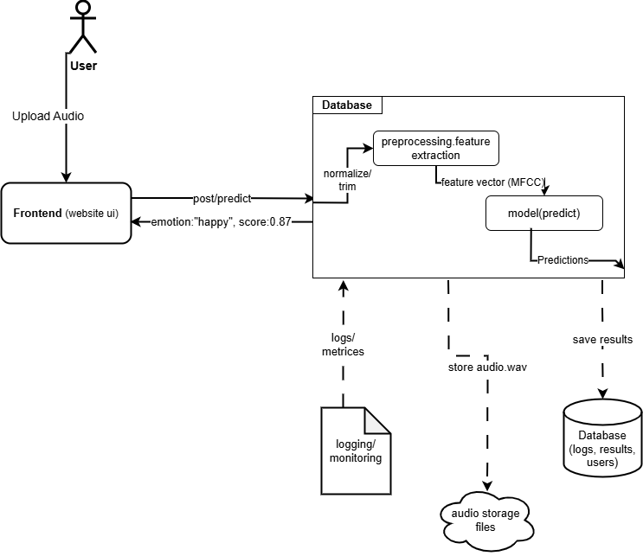

Figure 4.1: Client Server Architecture

Data Representation

To effectively capture and communicate the internal flow and structure of the Speech Emotion Recognition (SER) system, various data representation techniques are used. These include diagrams that illustrate system processes, the sequence of user interactions, and the flow of data between different components. These visual representations help in understanding how audio input is processed, how features are extracted, and how the deep learning model generates emotion predictions.

The diagrams also demonstrate how the web interface interacts with the backend system and how results are delivered to the user. Each representation contributes to better architectural clarity, making it easier to understand system functionality, support development, and simplify future maintenance and enhancements.

Process Flow/Representation

The process flow diagram illustrates the logical sequence of user interactions and system operations within the Speech Emotion Recognition (SER) system. It describes the step-by-step workflow followed by the system, starting from user input to the final emotion prediction. The process begins when a user accesses the web-based interface and is provided with the option to upload or record an audio sample. This makes the system simple and accessible for users to interact with.

Once the audio input is provided, the system sends the data to the backend server for further processing. In the first stage, the audio undergoes preprocessing, where noise is reduced, and the audio signal is converted into a standardized format suitable for analysis. This step ensures that the input data is clean and consistent for accurate processing.

After preprocessing, the system performs feature extraction using techniques such as Mel Frequency Cepstral Coefficients (MFCC). These features capture important characteristics of speech, including tone, pitch, and frequency patterns, which are essential for identifying emotions. The extracted features are then passed to the trained deep learning model.

In the next stage, the Convolutional Neural Network (CNN) model analyzes the features and classifies the audio into different emotional categories such as happiness, sadness, anger, or neutrality. The model processes the input efficiently and generates a prediction based on the learned patterns from the training data.
Once the emotion is predicted, the result is sent back to the web application, where it is displayed to the user in a clear and understandable format. This allows users to instantly view the detected emotion based on their speech input.

At any point, users can provide new audio input to perform another prediction, making the system interactive and dynamic. This structured process flow ensures smooth communication between system components and provides an efficient, accurate, and user-friendly experience for emotion recognition.

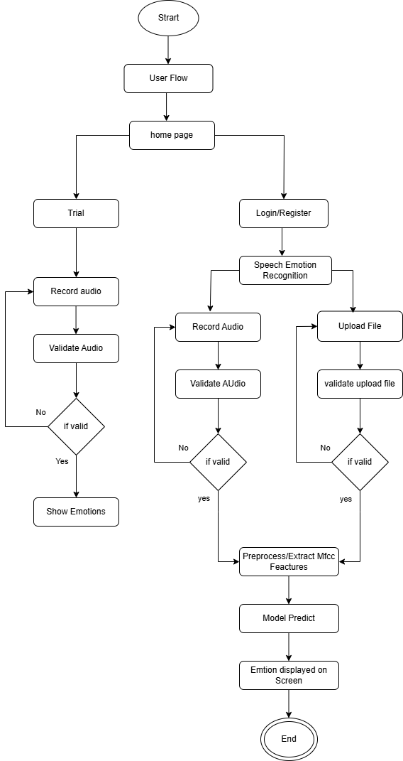

Figure 4.2: Process Flow Diagram

Sequence Diagram

The sequence diagram illustrates the dynamic flow of interactions between the user and various components of the Speech Emotion Recognition (SER) system. It represents the step-by-step sequence of messages exchanged between the web interface, backend server, audio processing modules, and the deep learning model. This helps in understanding how the system processes user input and generates emotion predictions in real time.

The process begins when a user accesses the web application and is provided with options to either upload an audio file or record speech directly. Once the user provides the audio input, the web interface sends this data to the backend server for processing.

Upon receiving the audio input, the backend initiates the preprocessing stage, where the audio is cleaned, normalized, and converted into a suitable format. After preprocessing, the system performs feature extraction using techniques such as Mel Frequency Cepstral Coefficients (MFCC), which capture essential characteristics of the speech signal.

These extracted features are then passed to the trained deep learning model, specifically a Convolutional Neural Network (CNN). The model analyzes the input features and classifies the speech into different emotional categories such as happiness, sadness, anger, or neutrality based on learned patterns.

Once the prediction is generated, the backend sends the result back to the web application. The web interface then displays the detected emotion to the user in a clear and understandable format. This entire process happens quickly, allowing users to receive real-time feedback.

Users can repeat this process by providing new audio inputs, making the system interactive and responsive. Throughout these interactions, the sequence diagram clearly demonstrates how different system components collaborate to process user requests efficiently and deliver accurate emotion recognition results. This representation is essential for understanding system behavior and ensuring smooth communication between all modules during development and future enhancements.

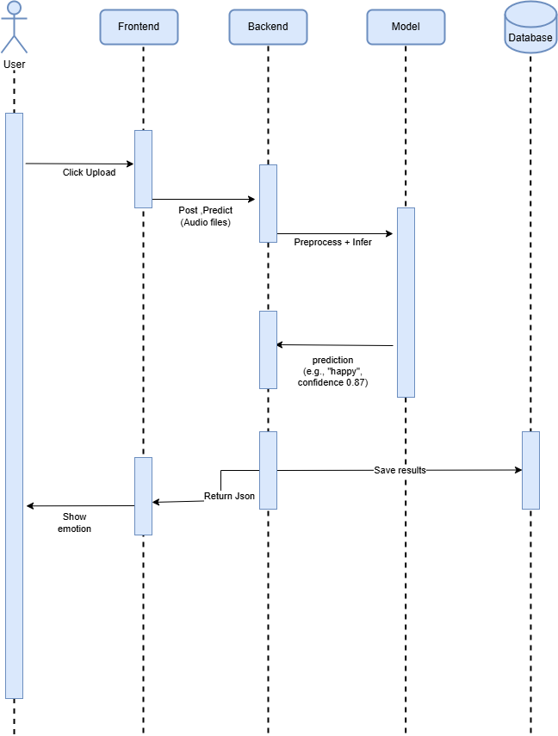

Figure 4.3: Sequence Diagram

Data Flow Diagram (Level 0)

The DFD Level 0 provides a high-level overview of the Speech Emotion Recognition (SER) system. It represents the system as a single process and shows its interaction with external entities.

In this system, the primary external entity is the user, who provides audio input in the form of recorded or uploaded speech. The SER system receives this input, processes it internally, and returns the predicted emotion as output. This level does not show internal details but focuses only on the overall input and output flow between the user and the system. It helps in understanding the system boundary and its main functionality in a simplified manner.

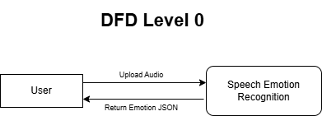

Figure 4.4: DFD Level 0 Diagram

Data Flow Diagram (Level 1)

The DFD Level 1 provides a more detailed representation of the Speech Emotion Recognition (SER) system by breaking down the main process into smaller sub-processes. It illustrates how data flows through different stages within the system.

At this level, the process begins when the user provides audio input through the web interface. The input is first sent to the preprocessing module, where the audio is cleaned and converted into a suitable format. After preprocessing, the system performs feature extraction using techniques such as MFCC to capture important characteristics of the speech signal.

The extracted features are then passed to the emotion classification module, where a trained deep learning model (CNN) analyzes the data and predicts the emotion. Finally, the predicted result is sent to the output module, where it is displayed to the user through the web interface.

This level clearly shows how different components of the system interact with each other and how data is transformed step by step to generate the final output. It provides a better understanding of the internal working of the system and supports effective system design and development.

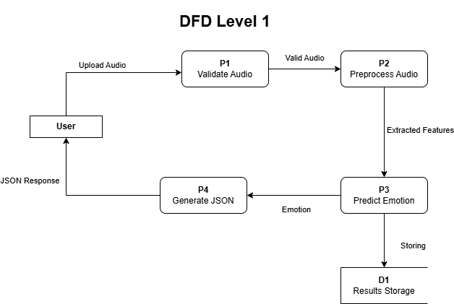

Figure 4.5: DFD Level 1 Diagram

Chapter 5

Implementation

Implementation

Dataset Description

The Dataset Description Include the Following:

- RAVDESS, CREMA-D, SAVEE, TESS
The development of a robust and generalizable Speech Emotion Recognition system requires training data that is sufficiently diverse in terms of speaker demographics, recording conditions, emotional expression styles, and acoustic characteristics. Relying on a single dataset introduces the risk of overfitting the model to the specific acoustic properties of that corpus, resulting in a system that performs well in controlled evaluations but degrades significantly when exposed to speech from different speakers or environments. For this reason, this project combines audio data from four established and widely validated benchmark corpora RAVDESS, CREMA-D, SAVEE, and TESS each of which contributes a distinct and complementary perspective to the combined training dataset.
- RAVDESS (Ryerson Audio-Visual Database of Emotional Speech and Song)
The RAVDESS dataset is one of the most extensively used and highly regarded benchmark corpora in Speech Emotion Recognition research. It was developed at Ryerson University in Canada and consists of high-quality audio and video recordings of emotional speech and song produced by 24 professional actors 12 male and 12 female under controlled studio conditions. Each actor recorded two lexically matched statements in a neutral North American accent, expressing eight distinct emotional categories neutral, calm, happy, sad, angry, fearful, disgusted, and surprised at two levels of emotional intensity: normal and strong. The audio recordings are stored in 24-bit, 48kHz WAV format, ensuring a high signal-to-noise ratio and consistent acoustic quality across all samples. The professional nature of the actors and the controlled studio recording environment make RAVDESS particularly valuable as a clean, high-quality training corpus, and its widespread adoption in the SER literature ensures that performance results obtained on this dataset are directly comparable with those reported in a large body of existing research. For this project, the speech-only audio files from RAVDESS were used, contributing a total of 1,440 audio samples across the eight emotion categories.
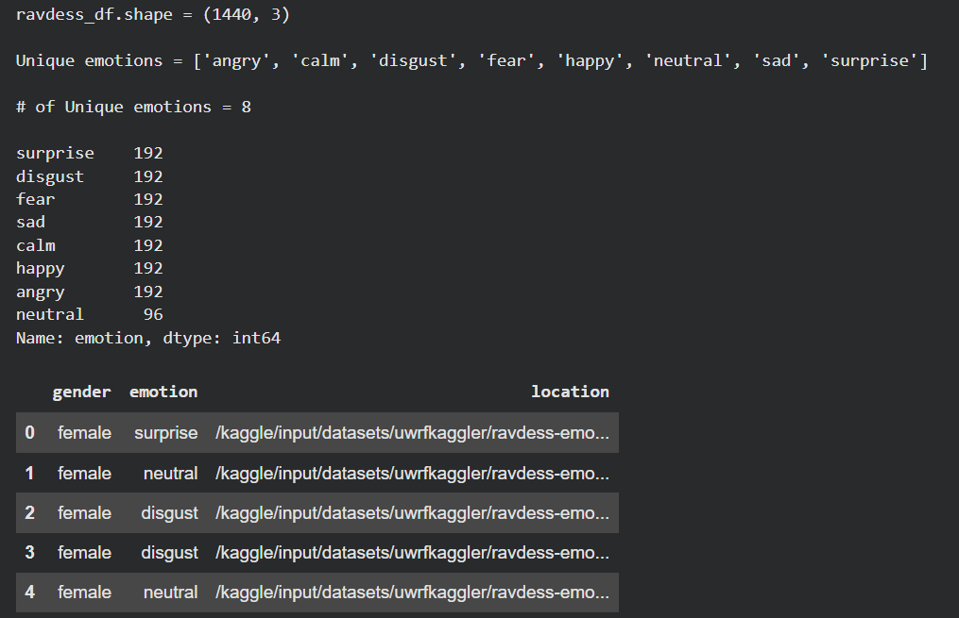

Figure 5.1: RADASS

- CREMA-D (Crowd-Sourced Emotional Multimodal Actors Dataset)
The CREMA-D dataset represents one of the largest and most demographically diverse emotional speech corpora currently available for SER research. It was developed through a crowd-sourced data collection process and contains 7,442 original audio clips recorded by 91 actors 48 male and 43 female spanning a wide range of ages from 20 to 74 years and representing a diverse mix of racial and ethnic backgrounds including African American, Asian, Caucasian, Hispanic, and Unspecified. Each actor performed 12 sentences drawn from a set of everyday conversational phrases, expressing six emotional categories anger, disgust, fear, happy, neutral, and sad at four different emotional intensity levels: low, medium, high, and unspecified. The demographic diversity of CREMA-D is its most significant contribution to the combined training dataset, as it exposes the model to a far broader range of speaker characteristics including variations in vocal quality, accent, and expressive style than any single demographically homogeneous corpus could provide. This diversity is critical for training a model that generalizes across real-world speakers rather than being tuned to the acoustic properties of a narrow demographic group.
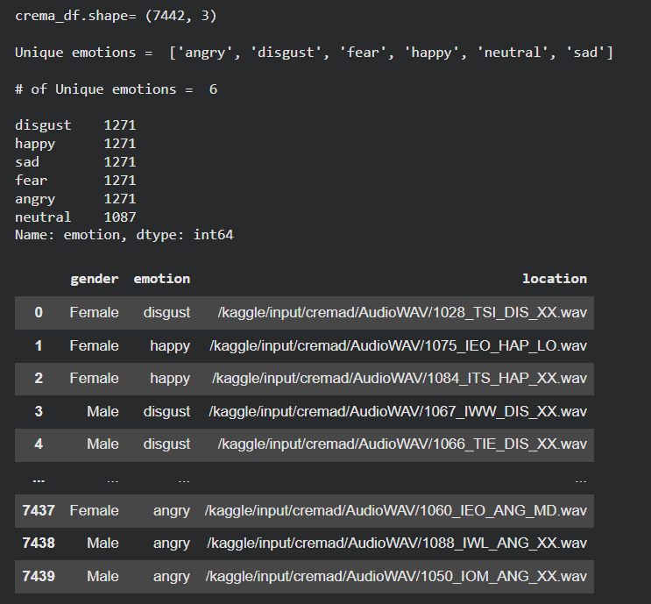

Figure 5.2: CREMA-D

- SAVEE (Surrey Audio-Visual Expressed Emotion)
The SAVEE dataset was developed at the University of Surrey in the United Kingdom and consists of audio-visual recordings of emotional speech produced by four male native English speakers identified as DC, JE, JK, and KL, who were postgraduate students or researchers at the university at the time of recording. The dataset contains 480 audio utterances in total, with each speaker recording 15 sentences per emotion across seven emotional categories anger, disgust, fear, happiness, neutral, sadness, and surprise. The sentences were drawn from the standard TIMIT sentence corpus and were selected to be phonetically balanced, ensuring that the acoustic diversity of the recordings was not artificially constrained by phonetic uniformity. Although SAVEE is the smallest of the four datasets used in this project in terms of total sample count, its contribution is significant for two specific reasons. First, it provides exclusively male speaker data, which balances the gender representation in the combined corpus alongside the female-dominant TESS dataset. Second, its phonetically balanced sentence design and naturalistic recording environment at a research institution rather than a professional studio contribute a degree of acoustic variability that complements the high-quality controlled recordings of RAVDESS and adds to the overall diversity of the training data.

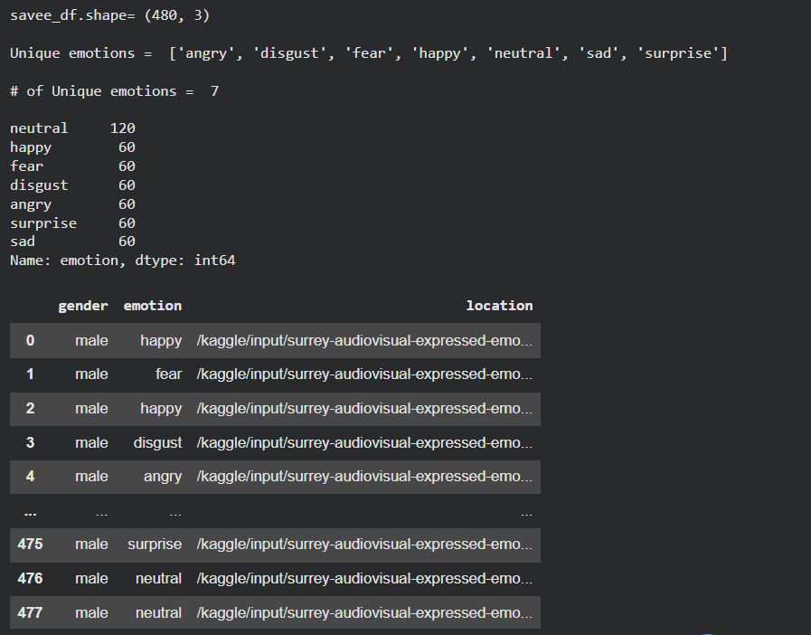

Figure 5.3: SAVEE

- TESS (Toronto Emotional Speech Set)
The TESS dataset was developed at the University of Toronto in Canada and consists of audio recordings produced by two female actors one aged 26 years and one aged 64 years, who were native English speakers with no hearing impairments. The dataset contains 2,800 audio files in total, with each actor recording 200 target words embedded within the carrier phrase "Say the word" and expressing each word across seven emotional categories anger, disgust, fear, happiness, pleasant surprise, neutral, and sadness. The recordings were made in a professional studio environment and are stored in high-quality WAV format with consistent acoustic properties across all samples. The inclusion of TESS in the combined training dataset serves two important purposes. First, it contributes a substantial volume of clearly labelled, high-quality female speaker data that complements the male speaker recordings of SAVEE and the mixed-gender recordings of RAVDESS and CREMA-D. Second, the age diversity between the two TESS speakers a 26-year-old and a 64-year-old introduces vocal quality variations associated with different age groups, further enriching the acoustic diversity of the combined training corpus and improving the model's ability to generalize across speakers of different ages.

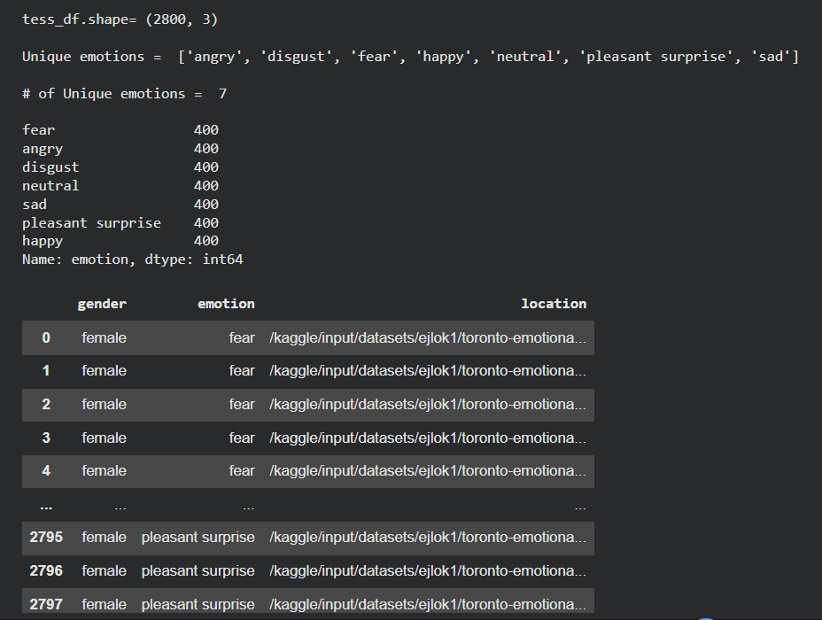

Figure 5.4: TESS

Table 5.1: Audio File Count by Dataset
Dataset | No. of Actors | Gender | Emotion Categories | Total Audio Files
RAVDESS | 24 | Male and Female | 8 (neutral, calm, happy, sad, angry, fearful, disgusted, surprised) | 1,440
CREMA-D | 91 | Male and Female | 6 (anger, disgust, fear, happy, neutral, sad) | 7,442
SAVEE | 4 | Male only | 7 (anger, disgust, fear, happiness, neutral, sadness, surprise) | 480
TESS | 2 | Female only | 7 (anger, disgust, fear, happiness, pleasant surprise, neutral, sadness) | 2,800
Total | 121 | Mixed | 7 (unified) | 12,162

The combined total of 12,162 audio files represents a substantial and diverse training corpus that is considerably larger and more demographically varied than any single source dataset used in isolation. This volume of labelled data provides the deep learning model with sufficient examples of each emotion class across a wide range of speaker characteristics and recording conditions to learn robust and generalizable acoustic representations of emotional speech. The unified emotion label schema adopted for the combined dataset maps the overlapping emotion categories across all four corpora onto seven common classes angry, disgust, fear, happy, neutral, sad, and surprise ensuring consistency in the class labels used during model training and evaluation regardless of the source dataset from which a given audio sample was drawn.

- Why these 4 datasets selected
The selection of the four datasets used in this project RAVDESS, CREMA-D, SAVEE, and TESS was not an arbitrary decision but the result of a deliberate and well-reasoned evaluation process guided by a set of clearly defined selection criteria. These criteria were established in direct response to the limitations identified in the existing SER literature, where the reliance on a single, demographically narrow, and acoustically homogeneous dataset was consistently identified as one of the primary causes of poor cross-speaker generalization and limited real-world applicability. Each of the four datasets was selected because it satisfies all of the core selection criteria while simultaneously contributing a unique and complementary characteristic that the other three datasets do not provide, resulting in a combined corpus that is greater in value than the sum of its individual parts.

The first and most fundamental selection criterion was public availability and academic accessibility. All four datasets are freely available to the research community without licensing restrictions or subscription costs, ensuring that the experimental methodology of this project is fully reproducible by any researcher or developer who wishes to replicate or extend the work. Commercial or proprietary datasets were explicitly excluded from consideration, as their restricted availability would undermine the open and transparent nature of this academic project and prevent independent verification of the reported results.

The second criterion was the availability of high-quality, clearly labelled audio recordings. The reliability of a supervised learning model is directly dependent on the quality and consistency of the labels assigned to its training data, a model trained on ambiguously or inconsistently labelled data cannot be expected to learn meaningful or reliable emotional representations. All four selected datasets provide audio recordings that were labelled by the actors themselves during performance or validated through crowd-sourced perceptual evaluation, ensuring a high degree of label reliability. RAVDESS and TESS in particular are notable for the studio-quality acoustic conditions under which their recordings were produced, providing the model with clean, noise-free examples of each emotion category that serve as a reliable acoustic reference during the early stages of training.

The third criterion was coverage of the target emotion categories. This project targets seven primary emotion categories angry, disgust, fear, happy, neutral, sad, and surprise, that collectively represent the most widely studied and practically significant emotional states in the SER literature. Each of the four selected datasets covers a substantial subset of these seven categories, and together they provide complete coverage of all seven target classes. No single dataset alone covers all seven emotion categories with sufficient sample volume, making the combination of multiple corpora a practical necessity rather than merely a desirable enhancement.

The fourth and most important criterion was demographic and acoustic diversity. The reviewed literature consistently demonstrated that SER models trained on a single, demographically homogeneous corpus such as a dataset recorded exclusively by young adult Caucasian professional actors generalize poorly to speakers from different age groups, ethnic backgrounds, genders, or non-professional vocal profiles. The four selected datasets were specifically chosen because together they provide a level of demographic diversity that no single dataset could achieve independently. RAVDESS contributes professionally recorded, balanced male and female speech from trained North American actors. CREMA-D contributes the greatest demographic breadth, with 91 actors spanning multiple age groups, genders, and ethnic backgrounds including African American, Asian, Caucasian, and Hispanic speakers. SAVEE contributes exclusively male speaker data from British English speakers recorded in a research university environment, introducing both gender specificity and accent variation. TESS contributes exclusively female speaker data from two speakers of distinctly different ages 26 and 64 introducing age-related vocal quality variation that none of the other three datasets provides. The combination of these four datasets therefore produces a training corpus that spans a wide range of speaker ages, genders, ethnicities, accents, and recording environments, collectively approximating the acoustic diversity of real-world speech far more closely than any individual corpus.

The fifth criterion was established use in the SER research community. All four datasets are extensively cited and widely used as benchmarks in peer-reviewed SER research, meaning that performance results obtained on these datasets are directly comparable with the published findings of a large body of existing work. This comparability is important for contextualizing the performance of the proposed system within the broader research landscape and for ensuring that the evaluation results reported in this project have recognized validity and academic credibility. The widespread adoption of these datasets also means that their characteristics, limitations, and potential biases are well documented in the literature, providing a solid foundation of prior knowledge that informed the design of the preprocessing, augmentation, and evaluation strategies adopted in this project.

Finally, the four datasets were selected in combination because their individual weaknesses are mutually compensating. RAVDESS is limited in demographic diversity but provides the highest acoustic quality. CREMA-D provides the greatest demographic breadth but contains a smaller number of emotion categories than the other datasets. SAVEE provides phonetically balanced male speaker data but contributes the smallest total sample volume. TESS provides a large volume of high-quality female speaker data but is limited to two speakers. By combining all four, the strengths of each dataset offset the limitations of the others, producing a unified training corpus that is more balanced, more diverse, and more acoustically representative than any single dataset could be and therefore a far more appropriate foundation for training a robust and generalizable Speech Emotion Recognition system.

Data Preprocessing

The Data Preprocessing include the following:

- Audio loading and sampling rate standardization (22050 Hz)
Data preprocessing is one of the most critical stages in the development of any machine learning system, and it is particularly important in the context of Speech Emotion Recognition where the quality, consistency, and format of the input audio data directly determine the reliability and meaningfulness of the acoustic features extracted in subsequent stages. Before any feature extraction or model training activity could commence, it was therefore necessary to load all audio files from the four source datasets into a consistent and computationally processable format and to standardize their acoustic properties to ensure uniformity across the entire combined corpus. The primary preprocessing operation performed at this stage was the loading of raw audio files and the standardization of their sampling rates to a uniform value of 22,050 Hz using the Librosa audio analysis library.

The sampling rate of a digital audio signal defines the number of samples captured per second of audio and directly determines the range of frequencies that the signal can represent. According to the Nyquist-Shannon sampling theorem, a digital audio signal sampled at a rate of 22,050 Hz is capable of representing all frequency components up to 11,025 Hz, a range that encompasses the vast majority of acoustically and emotionally relevant information present in human speech. The upper frequency limit of human speech, including the formant structures, pitch harmonics, and spectral envelope characteristics that are most informative for emotion recognition, falls well within this range, making 22,050 Hz a well-established and widely adopted standard sampling rate for speech processing applications in the SER research community.

The standardization of sampling rates across the combined dataset was a necessary preprocessing step because the four source corpora were originally recorded at different native sampling rates. RAVDESS was recorded at 48,000 Hz, reflecting the high-fidelity studio recording conditions under which it was produced. CREMA-D and SAVEE were recorded at 16,000 Hz, a standard sampling rate for speech research applications. TESS was recorded at 24,414 Hz. If these differences in native sampling rate were not corrected prior to feature extraction, the acoustic features computed from audio files of different sampling rates would not be directly comparable, as the same feature extraction parameters such as the number of MFCC coefficients, the FFT window size, and the hop length would correspond to different physical time and frequency resolutions depending on the sampling rate of the input signal. This inconsistency would introduce systematic biases into the feature matrix that could mislead the model during training and produce unreliable classification results.

To address this, all audio files across all four datasets were loaded using Librosa's core audio loading function with the target sampling rate explicitly set to 22,050 Hz. Librosa's audio loader automatically performs resampling during the loading process, converting any audio file whose native sampling rate differs from the specified target rate to the desired 22,050 Hz standard through high-quality resampling algorithms that preserve the perceptually relevant acoustic characteristics of the original signal. This single standardization operation ensured that every audio sample in the combined corpus, regardless of its source dataset or native recording format, was represented as a time-domain waveform at a consistent 22,050 Hz sampling rate before any subsequent processing was applied, establishing the uniform acoustic foundation upon which all downstream feature extraction operations were built.

In addition to sampling rate standardization, the audio loading stage also involved the conversion of all audio files to single-channel mono format, as stereo or multi-channel recordings introduce redundant information that is not necessary for emotion recognition from speech and would increase the computational cost of subsequent processing without providing any meaningful additional discriminative information. Librosa's audio loading function performs this mono conversion automatically during the loading process, ensuring that all loaded audio signals are represented as one-dimensional time-series arrays suitable for direct input to the feature extraction pipeline. The combination of sampling rate standardization at 22,050 Hz and automatic mono conversion therefore ensured that the output of the audio loading stage was a consistent, uniform, and computationally efficient representation of each audio sample in the combined corpus, providing a reliable and well-conditioned input to all subsequent preprocessing, augmentation, and feature extraction operations.

- Audio segmentation into 2.5 second chunks
Following the silence removal stage, all audio files in the combined dataset were segmented into uniform chunks of 2.5 seconds duration. This segmentation operation was a critical preprocessing step that ensured all audio samples fed into the feature extraction pipeline and subsequently into the deep learning model were of identical length, satisfying the fixed-size input requirement of the CNN-LSTM architecture and enabling consistent and directly comparable feature representations to be computed across the entire training corpus.

The requirement for uniform input length arises from the fundamental design of deep learning models, which expect all input samples to have identical dimensions. Audio recordings of variable duration produce feature matrices of variable size, and without a standardization strategy to address this variability, the model would be unable to process samples of different lengths within the same batch during training. While several strategies exist for addressing this problem including zero-padding shorter samples to the length of the longest sample in the dataset, or truncating all samples to a fixed maximum length segmentation into fixed-duration chunks was selected as the most appropriate approach for this project because it preserves the complete acoustic content of longer recordings rather than discarding portions of the signal through truncation, and avoids the introduction of artificial zero-valued padding that could distort the feature representations of shorter recordings.

The specific duration of 2.5 seconds was selected for several well-grounded reasons. First, the majority of audio recordings in all four source datasets RAVDESS, CREMA-D, SAVEE, and TESS have durations of approximately 2.5 to 3.5 seconds, meaning that a 2.5-second chunk length captures the majority of the acoustic content of most recordings without requiring significant padding or truncation. A chunk duration that closely matches the natural duration of the source recordings minimizes the information loss associated with segmentation and ensures that each chunk contains a complete and acoustically representative sample of the emotional speech it was drawn from. Second, 2.5 seconds is sufficiently long to capture the temporal dynamics of emotional speech including the pitch contours, energy trajectories, and rhythmic patterns that evolve over the duration of an utterance and are critical for distinguishing between emotionally similar categories. Third, 2.5 seconds is short enough to ensure that the feature matrices computed from each chunk remain computationally manageable in terms of memory and processing requirements, particularly given the volume of over 12,000 audio samples in the combined corpus.

The segmentation process was implemented using PyDub, which operates on audio signals in milliseconds. Each audio file, after silence removal, was divided into consecutive non-overlapping segments of 2,500 milliseconds duration starting from the beginning of the recording. For recordings whose total duration was not an exact multiple of 2.5 seconds, the final segment was handled carefully segments shorter than 2.5 seconds were either padded with zeros to reach the required length or discarded entirely depending on their duration relative to the minimum useful length threshold, ensuring that no artificially truncated or information-poor segments were included in the training data.

For the inference stage when the trained model is used to predict the emotion of a new, previously unseen audio recording through the Streamlit web application the segmentation pipeline was extended to handle audio files of arbitrary length. Longer audio recordings submitted for inference were automatically divided into consecutive 2.5-second chunks, with silence gaps first removed using PyDub's silence detection functionality to ensure that only acoustically active segments were passed to the model. Each valid chunk of at least 2.5 seconds duration was then independently processed through the feature extraction pipeline and classified by the trained model, and the final emotion prediction for the complete recording was determined by aggregating the individual chunk-level predictions typically by selecting the most frequently predicted emotion class across all chunks, effectively implementing a majority voting strategy that produces a single, stable emotion label for the entire input recording.

This two-stage approach to audio segmentation uniform chunking for training data preparation and automatic chunking for real-time inference ensured that the system behaved consistently across both its training and deployment contexts, with the same 2.5-second window governing the acoustic scope of every feature extraction operation regardless of whether the input audio was drawn from the training corpus or submitted by an end user through the web application interface. This consistency between training and inference preprocessing is a fundamental requirement for reliable model performance, as any mismatch between the preprocessing applied during training and that applied during deployment would introduce distributional shifts that could significantly degrade the model's classification accuracy on real-world inputs.
- Label encoding using LabelEncoder
Following the audio loading, silence removal, and segmentation stages, the next essential preprocessing operation involved the transformation of the categorical emotion labels associated with each audio sample into a numerical format suitable for input to the deep learning classification model. This process known as label encoding is a fundamental requirement of supervised machine learning, as neural networks and other computational models operate exclusively on numerical data and cannot directly process raw string-based categorical labels such as "angry", "happy", or "sad". The conversion of these string labels into a consistent and meaningful numerical representation is therefore a prerequisite for model training, and it must be performed carefully to ensure that the encoded labels accurately reflect the class structure of the emotion recognition problem without introducing unintended mathematical relationships between classes.

In this project, label encoding was implemented using Scikit-learn's LabelEncoder class a widely used and well-validated preprocessing utility that transforms a set of categorical string labels into a corresponding set of integer values by assigning each unique label a unique integer in the range zero to n minus one, where n is the total number of distinct classes. The LabelEncoder was fitted on the complete set of emotion labels drawn from all four source datasets RAVDESS, CREMA-D, SAVEE, and TESS after their individual label schemas had been harmonized into a unified set of seven common emotion categories: angry, disgust, fear, happy, neutral, sad, and surprise. Fitting the LabelEncoder on the complete combined label set ensured that every emotion class present in the dataset received a consistent integer assignment regardless of which source corpus a given audio sample was drawn from, preventing any inconsistency in the numerical representation of emotion classes across the combined training corpus.

The harmonization of emotion labels across the four datasets prior to encoding required careful attention because the original label schemas of the four corpora were not identical. RAVDESS, for example, uses the label "fearful" rather than "fear", and includes a "calm" category that has no direct equivalent in the other three datasets. CREMA-D uses abbreviated label codes such as "ANG", "DIS", "FEA", "HAP", "NEU", and "SAD" that required mapping to their full-word equivalents. SAVEE encodes emotions through filename prefixes "a" for anger, "d" for disgust, "f" for fear, "h" for happiness, "n" for neutral, "sa" for sadness, and "su" for surprise — that required parsing and expansion. TESS encodes emotion labels directly in the filename as complete words but uses "ps" as an abbreviation for "pleasant surprise". All of these corpus-specific label representations were mapped to a unified set of seven standard emotion category names before the LabelEncoder was applied, ensuring that the fitted encoder produced a single, consistent integer assignment for each emotion class regardless of how that class was originally labelled in its source dataset.

Once fitted, the LabelEncoder transformed the unified string labels into integer values for example, mapping "angry" to 0, "disgust" to 1, "fear" to 2, "happy" to 3, "neutral" to 4, "sad" to 5, and "surprise" to 6. These integer-encoded labels were then passed through a further transformation using Keras's to_categorical function, which converted the integer labels into one-hot encoded binary vectors of length seven one element per emotion class with a value of one at the position corresponding to the correct emotion class and zeros at all other positions. This one-hot encoding step was necessary because the model's output layer uses a Softmax activation function that produces a probability distribution over all seven emotion classes, and the categorical cross-entropy loss function used during training requires the ground-truth labels to be expressed as probability vectors of the same dimensionality as the model's output in order to compute the loss correctly.

The fitted LabelEncoder object was serialized and saved to disk using Python's Pickle library alongside the trained model at the conclusion of the training stage. This serialization was essential for ensuring consistency between the label encoding applied during training and that applied during inference, as the LabelEncoder must use exactly the same integer-to-class mapping during deployment as it used during training in order for the model's predicted integer outputs to be correctly decoded back into human-readable emotion category names for display in the Streamlit web application. By saving and reloading the same fitted LabelEncoder object at inference time, the project ensured that the complete preprocessing pipeline from raw audio input through label encoding to emotion prediction remained fully consistent and reproducible across both the training and deployment contexts of the system.

- Train/test split (80/20)
Once the audio features had been extracted and the emotion labels encoded, the complete dataset was partitioned into training and testing subsets using an 80/20 split ratio, implemented through Scikit-learn's train_test_split function. This meant that 80 percent of the total audio samples approximately 9,730 files from the combined corpus of 12,162 were allocated to the training set used to fit the model's parameters, while the remaining 20 percent approximately 2,432 files were reserved as a held-out test set used exclusively for final performance evaluation. The dataset was shuffled prior to splitting to ensure that samples from all four source corpora and all seven emotion categories were proportionally represented in both subsets, preventing any systematic bias in the composition of either partition that could artificially inflate or deflate the reported evaluation metrics.
The 80/20 ratio was selected as the most appropriate partitioning strategy for this project based on the total volume of available data and the requirements of both reliable model training and statistically meaningful evaluation. An 80 percent training allocation provides the model with a sufficiently large and diverse set of labelled examples to learn robust acoustic representations of all seven emotion categories across the full range of speaker demographics represented in the combined corpus. The 20 percent test allocation, corresponding to over 2,400 audio samples, provides a test set large enough to produce statistically stable estimates of classification accuracy, precision, recall, and F1-score across all seven emotion classes. The strict separation between training and test dsata ensured that the evaluation metrics reported for this system reflect genuine generalization performance on unseen audio samples rather than memorization of the training data, maintaining the integrity and credibility of the experimental results.

Data Augmentation

The Data Augmentation includes the following:

- Noise injection
Data augmentation is a widely adopted strategy in machine learning for artificially expanding the diversity and volume of training data by applying controlled transformations to existing samples, thereby exposing the model to a broader range of input variations during training and improving its ability to generalize to unseen data. In the context of Speech Emotion Recognition, data augmentation is particularly important because the four source datasets used in this project despite their collective diversity were all recorded under relatively controlled conditions that do not fully capture the acoustic variability encountered in real-world deployment environments. Without augmentation, a model trained exclusively on clean, studio-quality recordings risks learning representations that are highly sensitive to the specific acoustic conditions of the training data and therefore degrades significantly in performance when exposed to speech recorded in noisier or more variable real-world settings. Noise injection was the first and most directly impactful augmentation technique applied in this project, and its rationale and implementation are described in detail below.

Noise injection involves the addition of a controlled amount of random noise to the original clean audio signal, producing an augmented version of the recording that simulates the acoustic conditions of real-world environments where background noise from sources such as traffic, ventilation systems, crowd chatter, or electronic interference is commonly present. In this project, Gaussian white noise, a type of random noise whose amplitude values follow a normal distribution and whose energy is distributed uniformly across all frequencies was added to each original audio sample during the augmentation stage. Gaussian white noise was selected as the noise type because its uniform frequency distribution makes it a conservative and broadly representative approximation of the wide variety of real-world noise sources that a deployed SER system might encounter, without making specific assumptions about the spectral characteristics of any particular noise environment.

The noise injection process was implemented using NumPy by generating a random noise array of the same length as the original audio waveform, scaling its amplitude by a noise factor that controlled the signal-to-noise ratio of the augmented sample, and adding the scaled noise array element-wise to the original waveform. The noise factor was carefully calibrated to produce augmented samples in which the added noise was perceptible and acoustically significant sufficient to challenge the model and improve its robustness while remaining low enough that the emotional content of the original speech signal was not obscured or rendered unrecognizable. Each original audio sample in the training set was augmented with noise injection to produce one additional training sample, effectively increasing the volume of training data and ensuring that the model encountered both clean and noisy versions of each emotional utterance during the learning process. This exposure to degraded versions of the training samples during learning directly improved the model's tolerance to acoustic noise at inference time, making the deployed system more reliable and robust when processing audio inputs recorded outside controlled laboratory conditions.
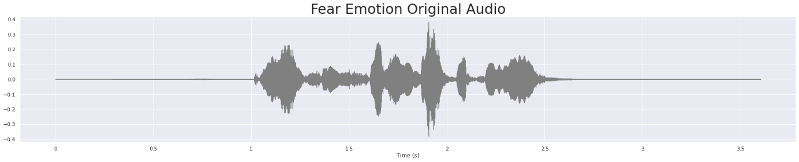

Figure 5.5: Fear Emotion Original Audio

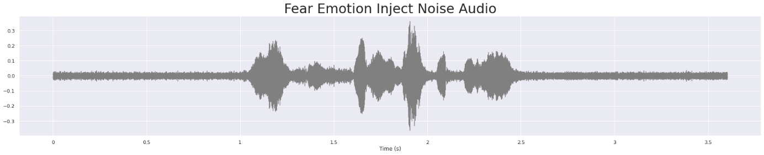

Figure 5.6: Fear Emotion Inject Noise Audio

- Pitch shifting
Pitch shifting is an audio augmentation technique that modifies the fundamental frequency of a speech signal commonly referred to as its pitch by a specified number of semitones while preserving the original duration and temporal structure of the recording. In the context of this project, pitch shifting was applied to the training audio samples using Librosa's pitch shift function, which implements a high-quality frequency-domain pitch transposition algorithm that alters the perceived pitch of the speaker's voice without introducing the speed and duration changes that would result from simple resampling. The primary motivation for applying pitch shifting as an augmentation strategy was to simulate the natural variation in vocal pitch that exists across different speakers, as individuals differ significantly in their fundamental frequency range based on factors including gender, age, and physiological vocal tract characteristics. By exposing the model to pitch-shifted versions of the training samples during learning, the augmentation process effectively presented the model with synthetic approximations of how the same emotional utterance might sound when produced by speakers with higher or lower natural pitch ranges than those represented in the original training data, thereby improving the model's ability to generalize across speakers of diverse vocal profiles. Each training sample was augmented by shifting its pitch by a randomly selected value within a defined semitone range, producing one additional training sample per original recording and further expanding the acoustic diversity of the combined training corpus.

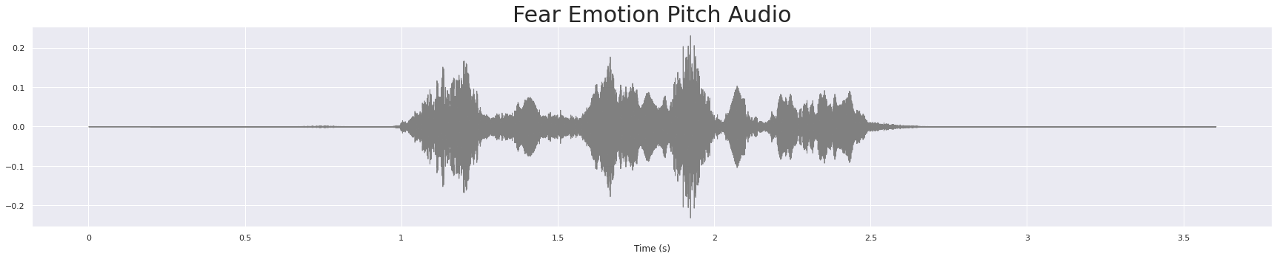

Figure 5.7: Fear Emotion Pitch Audio

- Time stretching
Time stretching is an audio augmentation technique that modifies the duration and tempo of a speech signal by a specified rate factor while preserving the original pitch and frequency characteristics of the recording. In this project, time stretching was applied to the training audio samples using Librosa's time stretch function, which implements a phase vocoder algorithm that compresses or expands the temporal structure of the audio signal without altering its perceived pitch or spectral envelope. The motivation for applying time stretching as an augmentation strategy was to simulate the natural variation in speaking rate that exists across different speakers and emotional states, as individuals vary considerably in the speed at which they deliver speech depending on their emotional arousal level, personal speaking habits, and situational context. A speaker expressing anger, for example, may speak faster than one expressing sadness, and these tempo differences are themselves acoustically informative cues for emotion recognition. By exposing the model to time-stretched versions of the training samples both compressed to simulate faster speaking rates and expanded to simulate slower ones the augmentation process improved the model's robustness to speaking rate variability and reduced its sensitivity to the specific tempos present in the original training recordings, contributing to a more generalizable and reliable emotion classification system.

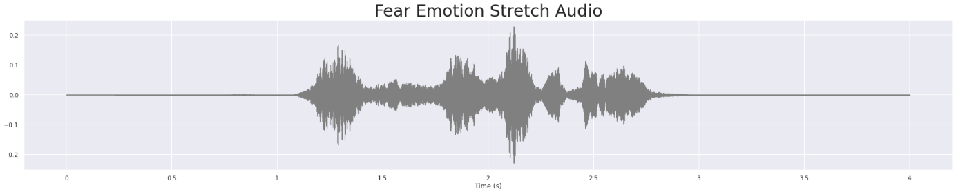

Figure 5.8: Fear Emotion Stretch Audio

- Why augmentation was necessary
The application of data augmentation in this project was necessary for two closely related and mutually reinforcing reasons. First, despite the substantial combined volume of over 12,000 audio samples drawn from four diverse corpora, all four source datasets were recorded under relatively controlled acoustic conditions that do not fully represent the range of acoustic variability encountered in real-world speech environments. A model trained exclusively on clean, controlled recordings without augmentation would learn feature representations that are highly specific to those conditions, making it vulnerable to significant performance degradation when deployed in environments where background noise, variable speaking rates, and diverse vocal pitch ranges are inevitable. Second, deep learning models with large numbers of trainable parameters are inherently susceptible to overfitting when the training data does not contain sufficient variability to prevent the model from memorizing corpus-specific acoustic patterns rather than learning genuinely generalizable emotional representations. By applying noise injection, pitch shifting, and time stretching, the augmentation strategy artificially introduced the kind of acoustic variability that the model would encounter in real-world deployment, effectively regularizing the learning process and producing a trained model that is more robust, more generalizable, and better suited to practical application than one trained on the original unaugmented data alone.

Feature Extraction

Feature extraction is the process of transforming raw audio waveforms into structured numerical representations that capture the acoustically and emotionally relevant characteristics of the speech signal in a format suitable for input to the deep learning model. In this project, six complementary acoustic feature types were extracted from each audio sample using the Librosa library, each chosen for its specific capacity to capture a distinct dimension of emotional speech that the others alone cannot fully represent.

- MFCCs (Mel-Frequency Cepstral Coefficients)
MFCCs are the most widely used and extensively validated acoustic features in Speech Emotion Recognition research. They represent the short-term spectral envelope of the speech signal on a perceptually motivated mel frequency scale that approximates the non-linear frequency sensitivity of the human auditory system. In this project, 40 MFCC coefficients were extracted from each audio sample, capturing the overall shape of the spectral envelope across the duration of the utterance. The 40-coefficient configuration was selected as it provides sufficient spectral resolution to capture emotionally discriminative timbral characteristics without introducing unnecessary dimensionality that could increase computational cost and the risk of overfitting.

Figure 5.9: MFCCs

- Mel-Spectrogram
The mel-spectrogram represents the energy distribution of the speech signal across both time and frequency, computed on the perceptually motivated mel scale. Unlike MFCCs which compress the spectral information into a compact coefficient vector, the mel-spectrogram preserves the full time-frequency structure of the signal, providing the convolutional layers of the CNN component with a rich two-dimensional representation from which local spectral and temporal patterns can be extracted. The mel-spectrogram therefore serves as the primary input to the CNN layers of the hybrid architecture, complementing the compact statistical summaries provided by the other feature types.

Figure 5.10: Mel Spectrogram
- Chroma Features
Chroma features capture the distribution of energy across the twelve pitch classes of the musical octave corresponding to the twelve semitones from C to B and represent the tonal and harmonic content of the speech signal. While chroma features are more commonly associated with music analysis, they have demonstrated utility in SER by capturing pitch-related characteristics of emotional speech such as the rising intonation patterns associated with surprise or the falling contours associated with sadness. Their inclusion in the feature set enriches the pitch-related information available to the model beyond what is captured by the fundamental frequency alone.

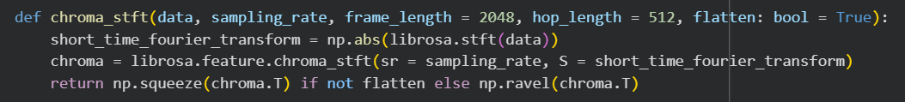

Figure 5.11: Chroma Features

- Zero Crossing Rate
Zero Crossing Rate measures the rate at which the audio signal changes sign that is, the number of times per unit time that the waveform crosses the zero amplitude axis. ZCR is a simple but informative time-domain feature that provides an indirect measure of the noisiness and frequency content of the signal. Emotions characterized by high arousal and vocal tension, such as anger and fear, typically exhibit higher zero crossing rates than low-arousal emotions such as sadness and neutral, making ZCR a useful discriminative feature for distinguishing between high and low arousal emotional states.

Figure 5.12: Zero Crossing Rate

- Root Mean Square Energy
Root Mean Square Energy measures the overall loudness or energy of the audio signal over time by computing the square root of the mean of the squared amplitude values within each analysis frame. RMSE is directly related to the perceived volume and intensity of the speech signal and captures the energy dynamics that vary significantly across emotional states. High-energy emotions such as anger and happiness are associated with elevated RMSE values, while low-energy emotions such as sadness and neutral exhibit lower and more stable energy profiles, making RMSE an important complement to the spectral features in the overall feature set.

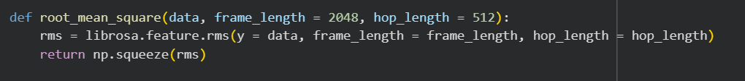

Figure 5.13: Root Mean Square

- Spectral Entropy
Spectral Entropy measures the complexity and unpredictability of the frequency distribution of the speech signal, quantifying how evenly the signal's energy is spread across the frequency spectrum. A signal with energy concentrated in a small number of frequency bands such as a pure tone has low spectral entropy, while a signal with energy distributed broadly and uniformly across the spectrum such as white noise or highly aroused emotional speech has high spectral entropy. Spectral Entropy was included in the feature set because it provides a measure of vocal complexity and irregularity that complements the energy and spectral envelope features captured by RMSE and MFCCs respectively, and it has demonstrated discriminative value for distinguishing between emotionally neutral and emotionally aroused speech in the SER literature.

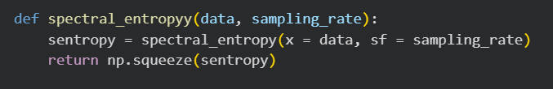

Figure 5.14: Spectral Entropy

- How Librosa Was Used
All six acoustic feature types described above were extracted from the preprocessed audio samples using the Librosa library, a comprehensive and well-documented Python package for audio and music analysis that provides efficient implementations of a wide range of signal processing and feature extraction algorithms. For each audio sample, Librosa's dedicated feature extraction functions were called sequentially librosa.feature.mfcc for MFCCs, librosa.feature.melspectrogram for the mel-spectrogram, librosa.feature.chroma_stft for chroma features, librosa.feature.zero_crossing_rate for ZCR, librosa.feature.rms for RMSE, and antropy.spectral_entropy for Spectral Entropy. The extracted features were computed frame-by-frame across the duration of each 2.5-second audio chunk and then summarized by computing the mean value of each feature across all frames, producing a fixed-length feature vector for each audio sample regardless of minor variations in the exact number of frames. These feature vectors were concatenated into a single unified feature matrix and stored as NumPy arrays, forming the complete input representation passed to the CNN-LSTM model during training and inference.

Model Architecture

The model architecture include the following:

- CNN Layers Purpose
The Convolutional Neural Network layers form the first component of the hybrid architecture and are responsible for extracting local spatial and spectral patterns from the acoustic feature representations provided as input to the model. Convolutional layers operate by applying a set of learnable filters also referred to as kernels across the input feature map in a sliding window fashion, with each filter detecting the presence of a specific local pattern at each position in the input. The fundamental advantage of convolutional layers over fully connected layers for this task is their ability to learn spatially local and translationally invariant feature detectors, meaning that a pattern recognized at one position in the feature map can be recognized equally well at any other position, regardless of where in the temporal sequence it occurs. This property is particularly valuable for emotion recognition, where emotionally discriminative acoustic patterns such as a sharp energy peak associated with anger or a gradual pitch fall associated with sadness may occur at different temporal positions in different utterances of the same emotion class.

In this project, multiple convolutional layers were stacked sequentially, with each layer learning increasingly abstract and high-level representations of the input features. The early convolutional layers learned low-level acoustic patterns such as local energy concentrations and spectral peaks, while the deeper convolutional layers combined these low-level patterns into higher-level representations corresponding to more complex acoustic structures that are characteristic of specific emotional states. MaxPooling layers were inserted between convolutional layers to progressively reduce the spatial dimensionality of the feature maps, retaining only the most salient activations and reducing the computational cost of subsequent layers while also introducing a degree of translational invariance that improves the model's robustness to small temporal shifts in the positions of acoustic features.
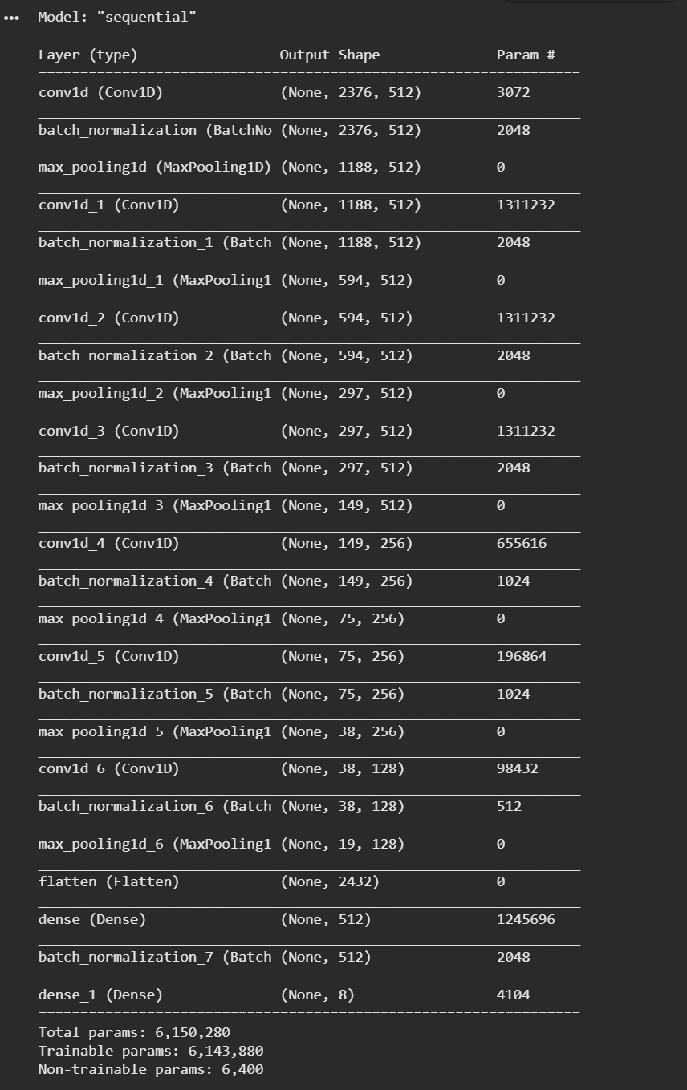

Figure 5.15: CNN Layers
- LSTM Layers Purpose
The Long Short-Term Memory layers form the second component of the hybrid architecture and are responsible for modelling the sequential temporal dependencies in the acoustic feature representations produced by the preceding convolutional layers. LSTMs are a specialized form of Recurrent Neural Network designed to address the vanishing gradient problem that prevents standard recurrent networks from learning long-range temporal dependencies in sequential data. LSTM units achieve this through a gating mechanism comprising three learned gates the input gate, the forget gate, and the output gate that collectively regulate the flow of information into, within, and out of each unit's internal memory cell, enabling the network to selectively retain relevant information over extended temporal sequences and discard irrelevant information that does not contribute to the classification decision.

In the context of this project, the LSTM layers processed the sequential output of the convolutional layers frame by frame, building up a temporal representation of the emotional dynamics of each utterance across its 2.5-second duration. This sequential processing capability is critical for distinguishing between emotion classes whose spectral characteristics are similar but whose temporal evolution patterns differ significantly for example, the pitch trajectory of a fearful utterance may follow a different temporal pattern from that of a surprised utterance even if their short-term spectral properties are acoustically similar, and only a model with explicit temporal modelling capability can reliably exploit this distinction.

- Dropout Regularization
Dropout is a regularization technique that was applied throughout the hybrid CNN-LSTM architecture to prevent overfitting the tendency of deep learning models with large numbers of trainable parameters to memorize the specific patterns of the training data rather than learning genuinely generalizable representations. During each training iteration, dropout randomly sets a specified proportion of neuron activations to zero, effectively removing those neurons from the network for that particular forward and backward pass. This stochastic deactivation forces the network to learn redundant and distributed representations that do not rely on any single neuron or small group of neurons, making the learned representations more robust and less sensitive to the specific idiosyncrasies of individual training samples. Dropout layers were inserted after both the convolutional and LSTM components of the architecture, with dropout rates carefully tuned during the experimental phase to achieve the optimal balance between model capacity and generalization performance.

- Dense Output Layer with Softmax
The final component of the model architecture is a fully connected Dense output layer with a Softmax activation function that produces the model's emotion classification output. The Dense layer takes the high-level feature representation produced by the preceding CNN and LSTM components and maps it to a vector of seven values one for each of the seven target emotion categories. The Softmax activation function then transforms these raw output values into a probability distribution over the seven emotion classes, ensuring that all output values are positive and sum to exactly one, with each value representing the model's estimated probability that the input audio sample belongs to the corresponding emotion category. The emotion class with the highest predicted probability is selected as the final classification output, providing a single, interpretable emotion label for each input audio sample processed by the system.

- Activation Functions
Activation functions introduce non-linearity into the neural network, enabling it to learn and represent the complex, non-linear relationships between acoustic input features and emotion class labels that cannot be captured by purely linear transformations. The Rectified Linear Unit activation function commonly referred to as ReLU was used as the activation function for all convolutional and fully connected hidden layers in the architecture. ReLU computes the function f(x) = max(0, x), setting all negative activations to zero while passing positive activations unchanged. This simple non-linearity is computationally efficient, mitigates the vanishing gradient problem during backpropagation by maintaining a constant gradient for positive activations, and has been empirically demonstrated to produce faster convergence and better generalization performance than sigmoid or hyperbolic tangent activations in deep convolutional architectures. The Softmax activation function used in the output layer, as described above, is distinct from the hidden layer activations and serves the specific purpose of converting raw output scores into a normalized probability distribution suitable for multi-class classification.

Model Training

The model training stage represents the process through which the hybrid CNN-LSTM architecture learned to associate the acoustic feature representations of emotional speech with their corresponding emotion class labels by iteratively adjusting its internal parameters weights and biases in response to the error signal produced by comparing its predictions against the ground-truth labels of the training data. The training process in this project was governed by a carefully selected set of configuration choices including the loss function, optimizer, training callbacks, batch size, and epoch count, each of which played a specific and well-reasoned role in shaping the quality and efficiency of the learning process.

- Loss Function (Categorical Cross Entropy)
The loss function defines the mathematical measure of discrepancy between the model's predicted output and the true class label for each training sample, and its value is minimized during training through the backpropagation algorithm. Categorical Cross Entropy was selected as the loss function for this project because it is specifically designed for multi-class classification problems in which each input sample belongs to exactly one of multiple mutually exclusive classes precisely the structure of the seven-class emotion recognition problem addressed by this system. Categorical Cross Entropy measures the divergence between the model's predicted probability distribution over the seven emotion classes and the true one-hot encoded label vector, penalizing the model heavily when it assigns a low probability to the correct class and rewarding it when the predicted probability distribution is closely aligned with the ground truth. This property makes Categorical Cross Entropy particularly well suited to training a Softmax-output classifier, as it directly optimizes the probability assigned to the correct emotion class rather than optimizing a generic distance measure that may not align well with the classification objective.

- Optimizer Adam
The optimizer determines the algorithm used to update the model's parameters in response to the gradient of the loss function computed during backpropagation. The Adam optimizer an abbreviation of Adaptive Moment Estimation was selected for this project because it combines the advantages of two earlier adaptive learning rate optimization algorithms AdaGrad and RMSProp into a single method that is both computationally efficient and well-suited to the noisy, high-dimensional optimization landscapes characteristic of deep learning training. Adam maintains a separate adaptive learning rate for each model parameter by computing running estimates of both the first moment the mean and the second moment the uncentered variance of the gradients, using these estimates to scale the parameter updates in a way that automatically adjusts the effective learning rate for each parameter based on the historical magnitude of its gradients. Parameters that receive consistently large gradients are updated with smaller steps, while parameters that receive small or infrequent gradients are updated with larger steps, producing a more balanced and efficient optimization trajectory than a fixed global learning rate would achieve. Adam's robustness to the choice of initial learning rate and its fast convergence properties made it the most appropriate optimizer for the training of the CNN-LSTM model in this project.

- Callbacks EarlyStopping and ReduceLROnPlateau
Two training callbacks were employed during the model training process to improve the efficiency and quality of the learning procedure and to prevent the common failure modes of overfitting and training stagnation.

The EarlyStopping callback monitored the validation loss at the end of each training epoch and automatically halted the training process when no improvement in validation loss was detected over a specified number of consecutive epochs referred to as the patience parameter. This mechanism prevented the model from continuing to train after the point of optimal generalization had been reached, avoiding the overfitting that inevitably occurs when a model is trained for too many epochs and begins to memorize the specific patterns of the training data at the expense of its ability to generalize to unseen samples. By terminating training at the epoch of minimum validation loss rather than at a fixed predetermined epoch count, EarlyStopping ensured that the saved model represented the best generalization performance achieved during the entire training run rather than the final state of a potentially overfit model.
The ReduceLROnPlateau callback complemented EarlyStopping by monitoring the validation loss and automatically reducing the learning rate by a specified factor whenever no improvement was detected over a defined number of consecutive epochs. When the model's validation performance plateaus, reducing the learning rate allows the optimizer to take smaller, more precise steps in the parameter space, enabling it to escape shallow local minima and converge more closely to a well-generalized solution than it could achieve with the original learning rate. This adaptive learning rate reduction strategy is particularly valuable in the later stages of training when the model is close to convergence and large learning rate steps would cause the optimization trajectory to overshoot the minimum, oscillating around it without ever settling into a stable optimum.

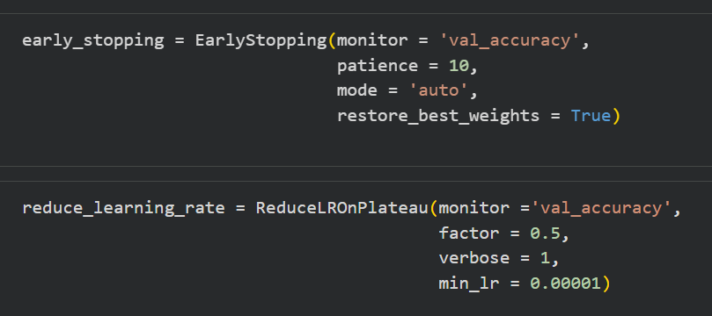

Figure 5.16: Callbacks Early Stopping

- Batch Size and Epochs
The batch size defines the number of training samples processed in each forward and backward pass before the model's parameters are updated, while the number of epochs defines the maximum number of complete passes through the entire training dataset that the training process is permitted to perform. In this project, a batch size of 32 was used during training a widely adopted default value that provides a good balance between the computational efficiency of processing multiple samples simultaneously and the stochastic variability of the gradient estimates that helps the optimizer escape local minima and explore the parameter space more effectively than large batch sizes allow. A smaller batch size introduces more noise into the gradient estimates, which acts as an implicit regularizer that can improve generalization, while a larger batch size produces more accurate but smoother gradient estimates that may converge to sharper minima with poorer generalization properties. The maximum number of training epochs was set to a sufficiently large value to ensure that the model had ample opportunity to converge, with the EarlyStopping callback responsible for terminating training at the appropriate point before overfitting occurred, meaning that the actual number of epochs completed during training was determined empirically by the model's validation performance trajectory rather than by a fixed predetermined limit.

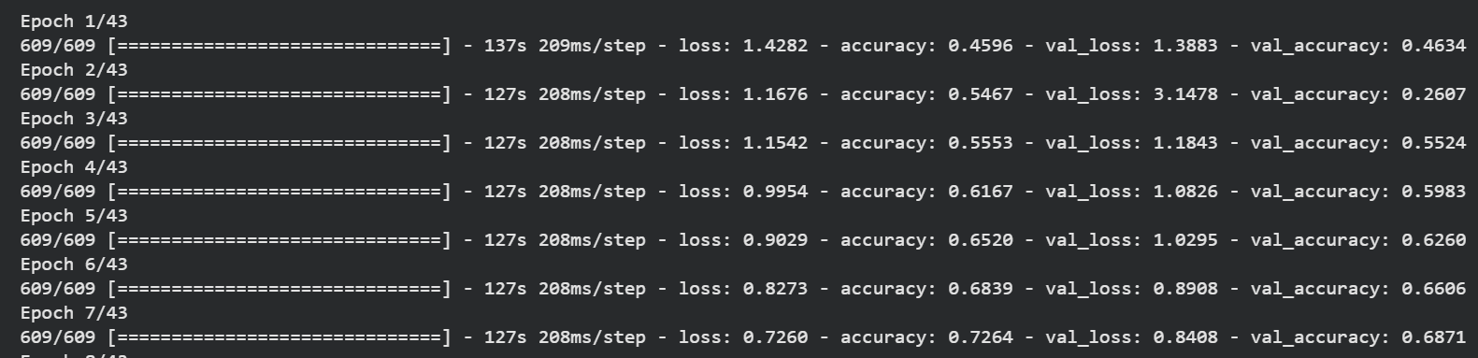

Figure 5.17: Epochs

- GPU Acceleration on Kaggle
The training of a deep learning model on a dataset of over 12,000 audio samples with a complex hybrid CNN-LSTM architecture and multiple feature extraction operations is a computationally intensive task that would be prohibitively slow on standard CPU hardware. This project was developed and trained on the Kaggle cloud platform, which provided access to a GPU-accelerated computing environment specifically a NVIDIA Tesla P100 GPU with 16 gigabytes of dedicated GPU memory that enabled the parallel processing of matrix operations across thousands of cores simultaneously. GPU acceleration reduced the per-epoch training time from what would have been several hours on CPU hardware to a matter of minutes, making it feasible to conduct multiple experimental training runs with different hyperparameter configurations within the time constraints of this project. TensorFlow's built-in GPU support automatically detected and utilized the available GPU hardware during training without requiring any modifications to the model definition or training code, and the Kaggle environment's pre-configured deep learning software stack ensured that all required CUDA and cuDNN dependencies were available and correctly configured from the outset of the project.

Model Evaluation

The model evaluation stage involved the systematic and rigorous assessment of the trained CNN-LSTM model's classification performance on the held-out test set using a comprehensive set of quantitative metrics. Evaluating the model on data it had never encountered during training was essential for obtaining an unbiased estimate of its generalization capability the ability to correctly classify emotional speech samples drawn from the same distribution as the training data but not seen during the learning process. The evaluation framework employed in this project comprised four standard classification metrics accuracy, precision, recall, and F1-score supplemented by a confusion matrix and a detailed classification report, together providing a complete and nuanced picture of the model's performance across all seven emotion categories.

- Accuracy, Precision, Recall, and F1-Score
Classification accuracy is the most straightforward and widely reported performance metric in machine learning, defined as the proportion of correctly classified test samples out of the total number of test samples. While accuracy provides a useful high-level summary of overall model performance, it is an insufficient measure on its own in the context of a seven-class emotion recognition problem where the distribution of samples across emotion classes may not be perfectly uniform. A model that performs well on the most frequently represented emotion classes but poorly on rarer classes can achieve a misleadingly high overall accuracy that does not reflect its true classification capability across all seven categories. For this reason, the evaluation was extended to include per-class precision, recall, and F1-score metrics that provide a more granular and informative assessment of performance at the individual emotion class level.

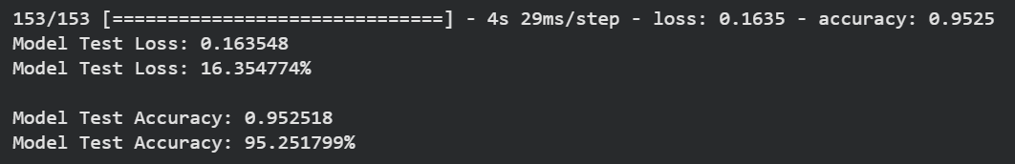

Precision measures the proportion of samples predicted as belonging to a given emotion class that were correctly classified in other words, the reliability of the model's positive predictions for each class. A high precision value for a given emotion class indicates that when the model predicts that class, it is correct the majority of the time, while a low precision value indicates a high rate of false positive predictions for that class. Recall, by contrast, measures the proportion of actual instances of a given emotion class that the model successfully identified capturing the model's sensitivity to each class and indicating how well it avoids false negatives. The F1-score is the harmonic mean of precision and recall for each class, providing a single balanced performance figure that accounts for both false positives and false negatives simultaneously and is particularly informative for evaluating performance on classes where precision and recall trade off against each other. These per-class metrics were computed for all seven emotion categories using Scikit-learn's classification_report function, enabling a detailed and class-specific assessment of the model's strengths and weaknesses across the full range of target emotions.

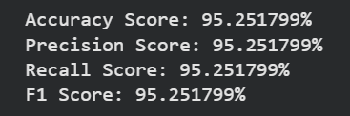

Figure 5.18: Accuracy, Precision, Recall, and F1-Score

- Confusion Matrix
The confusion matrix is a square matrix of dimension equal to the number of classes in this case seven by seven in which each row represents the actual emotion class of the test samples and each column represents the predicted emotion class assigned by the model. Each cell in the matrix contains the count of test samples whose actual class corresponds to the row and whose predicted class corresponds to the column, with the diagonal cells representing correctly classified samples and the off-diagonal cells representing misclassifications. The confusion matrix provides the most detailed and diagnostically valuable representation of the model's classification behaviour, as it reveals not only how many samples were misclassified but also which specific pairs of emotion classes the model most frequently confused with each other.

The confusion matrix generated for this project was visualized as a colour-coded heatmap using Seaborn's heatmap function, with darker colours indicating higher cell counts and lighter colours indicating lower counts. This visualization made it immediately apparent which emotion classes were classified most reliably those with high counts concentrated along the diagonal and which pairs of classes were most frequently confused, as indicated by high off-diagonal counts. The most commonly observed confusions in SER systems and those anticipated in the evaluation of this model involve acoustically similar emotion pairs such as fear and sadness, disgust and anger, and neutral and sadness, whose acoustic characteristics overlap sufficiently to present genuine classification challenges even for well-trained deep learning models. The insights derived from the confusion matrix analysis were used to inform a reflective discussion of the model's limitations and to identify specific directions for future improvement in the concluding chapter of this report.

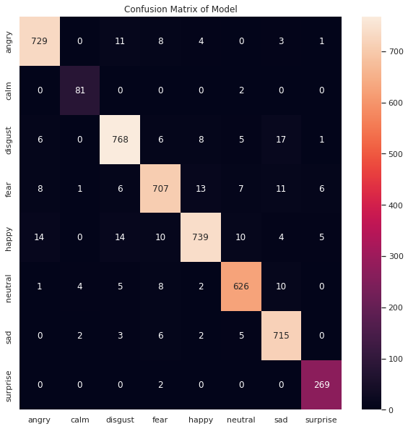

Figure 5.19: Confusion Matrix

- Classification Report
The classification report is a structured textual summary of the per-class precision, recall, and F1-score metrics described above, generated using Scikit-learn's classification_report function and presented in a tabular format that lists each of the seven emotion categories alongside its corresponding precision, recall, F1-score, and support values where support refers to the number of actual test samples belonging to each class. The classification report also includes macro-averaged and weighted-averaged summary statistics that aggregate the per-class metrics across all seven emotion categories, providing an overall performance summary that accounts for class-level variability in a more informative way than simple accuracy alone. The macro-average computes the unweighted mean of the per-class metrics, treating all emotion classes equally regardless of their sample count, while the weighted average weights each class's contribution to the overall metric by its support the number of test samples it contains producing a summary figure that reflects the model's performance on the emotion classes that appear most frequently in the test set. Together, the confusion matrix and classification report provided the comprehensive and multi-dimensional evaluation framework necessary to fully characterize the performance of the trained SER model and to assess its suitability for deployment in the Streamlit web application.

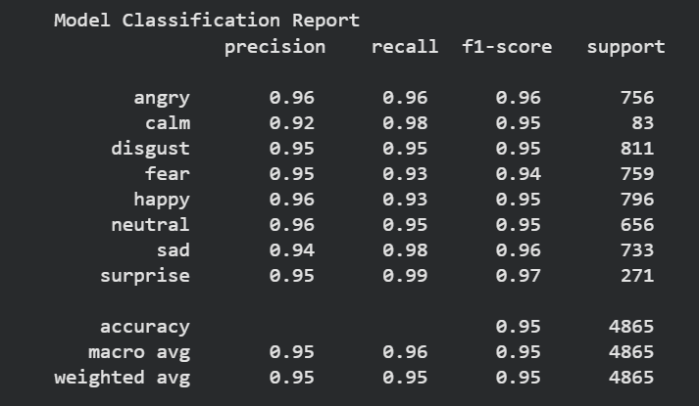

Figure 5.20: Classification Report

Model Deployment

The model deployment include the following:

- Model Saved Using Pickle
Upon completion of the training and evaluation process, the trained CNN-LSTM model and all associated preprocessing objects were serialized and saved to disk using Python's Pickle library. Pickle is a standard Python serialization module that converts arbitrary Python objects including trained Keras models, fitted Scikit-learn preprocessors, and NumPy arrays into a binary byte stream that can be written to a file and subsequently deserialized back into the original Python object in any compatible environment. The serialization of the trained model using Pickle was essential for decoupling the training and inference stages of the system, as it allowed the trained model to be loaded and used for prediction at any subsequent point in time without requiring the computationally expensive training process to be repeated. In addition to the trained CNN-LSTM model itself, the fitted LabelEncoder object used to encode and decode emotion class labels was also serialized using Pickle, ensuring that the complete preprocessing and postprocessing pipeline could be faithfully reconstructed at inference time using exactly the same object states that were established during training. The StandardScaler used for feature normalization was similarly serialized, guaranteeing that the feature scaling applied to new audio inputs during inference was identical to that applied during training a critical requirement for consistent and reliable model performance across both contexts.

- Streamlit Web Application
The trained and serialized model was deployed as an interactive web application built using the Streamlit framework a lightweight, Python-native open-source library specifically designed for the rapid development and deployment of data science and machine learning applications as browser-accessible web interfaces. Streamlit was selected as the deployment framework for this project because it enables the construction of fully functional, interactive web applications using pure Python code without requiring any knowledge of frontend web development technologies such as HTML, CSS, or JavaScript. This characteristic made Streamlit ideally suited to the deployment context of this academic project, where the priority was to demonstrate the practical capability of the trained SER model through an accessible and intuitive interface rather than to develop a production-grade commercial web application with complex frontend architecture.
The Streamlit application was structured as a single-page interface that loads the serialized model, LabelEncoder, and StandardScaler objects from disk upon initialization and presents the user with a clean and straightforward audio input interface. The application's backend logic implemented the complete inference pipeline audio loading, sampling rate standardization, silence removal, segmentation into 2.5-second chunks, feature extraction using Librosa, feature scaling using the loaded StandardScaler, model prediction using the loaded CNN-LSTM model, and label decoding using the loaded LabelEncoder as a sequence of Python function calls that are triggered automatically when the user provides an audio input and requests a prediction. The seamless integration of all pipeline components within the Streamlit application ensured that the end-to-end emotion recognition process was fully automated and transparent to the user, requiring no manual intervention or technical configuration between the submission of an audio input and the display of the predicted emotion label.

- Real-Time Audio Prediction Interface
The user-facing interface of the Streamlit web application provided an intuitive and accessible mechanism for submitting audio input to the trained SER model and receiving real-time emotion predictions. The interface allowed users to upload pre-recorded audio files in WAV format directly through the browser, providing flexibility for users who wished to test the system on existing recordings drawn from any source. Upon submission of an audio file, the application immediately invoked the complete inference pipeline described above, processing the input audio through all preprocessing and feature extraction stages before passing the resulting feature representation to the trained CNN-LSTM model for classification.

The predicted emotion label selected as the class with the highest predicted probability in the model's Softmax output was displayed prominently on the interface alongside the corresponding confidence score, expressed as the predicted probability value, giving the user an indication of the model's certainty in its prediction. For longer audio recordings whose duration exceeded 2.5 seconds, the application automatically segmented the input into consecutive 2.5-second chunks, generated individual predictions for each chunk, and aggregated the chunk-level predictions through a majority voting strategy to produce a single stable emotion label for the complete recording. The application also provided a visual display of the audio waveform and spectrogram of the submitted recording, enabling users to visually inspect the acoustic characteristics of their input alongside the model's prediction and developing an intuitive understanding of the relationship between the visual properties of the audio signal and the emotion class assigned by the system. This combination of real-time prediction, confidence scoring, majority voting for long recordings, and acoustic visualization collectively produced a deployment interface that was both practically functional and educationally informative, demonstrating the capabilities of the trained SER model in a manner that was accessible and meaningful to users regardless of their technical background.

Tools and Technologies

- Python, TensorFlow, Keras, Librosa
- Scikit-learn, Pandas, NumPy
- Matplotlib, Seaborn, Plotly
- Pydub, Antropy
- Kaggle GPU environment
- Streamlit

Algorithm

This section presents a natural language description of the algorithms underlying the five major functional modules of the Speech Emotion Recognition system, explaining the precise logical flow of each component from raw audio input through to final emotion prediction.

Algorithm 1: Data Preprocessing Pipeline

The data preprocessing algorithm accepts a raw audio file path as input and produces a list of clean, uniform-length audio chunks as output. The algorithm begins by loading the audio file using Librosa with a fixed target sampling rate of 22,050 Hz and converting it to mono format, ensuring consistency across all input samples regardless of their original recording format. The loaded audio signal is then converted into a PyDub AudioSegment object, upon which the silence detection and removal operation is applied using a minimum silence length of 100 milliseconds and a silence threshold of negative 45 decibels. All detected silence gaps satisfying these conditions are removed and the remaining acoustically active segments are concatenated back into a single continuous audio object. The cleaned audio is then divided into consecutive non-overlapping chunks of exactly 2.5 seconds duration by iterating through the signal in steps equal to the product of the target sampling rate and the chunk duration. Only chunks whose length exactly equals the required 2.5-second size are retained, ensuring that no truncated or information-poor segments are passed to subsequent processing stages. The resulting list of uniform-length audio chunks is returned as the output of the preprocessing algorithm and passed directly to the feature extraction stage.

Algorithm 2: Data Augmentation

The data augmentation algorithm accepts a clean audio signal and its sampling rate as input and produces a list of three augmented versions of the signal as output, each generated through a distinct transformation that simulates a different dimension of real-world acoustic variability. The first augmentation — noise injection — generates a Gaussian random noise array of the same length as the input signal, scales it by a noise factor of 0.035, and adds it element-wise to the original waveform, producing a noisy version of the recording that simulates background acoustic interference. The second augmentation — pitch shifting — selects a random pitch shift value within a range of negative three to positive three semitones and applies Librosa's pitch shift function to the original signal, producing a version of the recording whose perceived pitch is altered without changing its duration, simulating the vocal pitch variation that exists across different speakers. The third augmentation — time stretching — selects a random stretch rate between 0.8 and 1.2 and applies Librosa's time stretch function to the original signal, producing a version of the recording whose tempo is compressed or expanded without altering its pitch, simulating the speaking rate variation observed across different speakers and emotional states. All three augmented samples are appended to a list and returned alongside the original signal for inclusion in the training dataset.

Algorithm 3: Feature Extraction

The feature extraction algorithm accepts a preprocessed audio chunk and its sampling rate as input and produces a single concatenated feature vector as output. The algorithm sequentially applies six Librosa and Antropy feature extraction functions to the input signal. First, 40 Mel-Frequency Cepstral Coefficients are computed using Librosa's MFCC function, and their mean values across all frames are calculated to produce a 40-element vector. Second, a mel-spectrogram is computed and its per-band mean values are extracted to produce a fixed-length spectral representation. Third, chroma features are computed using the short-time Fourier transform and their mean values across all frames are extracted into a 12-element vector. Fourth, the Zero Crossing Rate is computed frame-by-frame and its mean value across the signal is extracted as a scalar feature. Fifth, the Root Mean Square Energy is computed frame-by-frame and its mean value is similarly extracted as a scalar. Sixth, the Spectral Entropy of the signal is computed using the Antropy library's spectral entropy function, producing a single scalar value representing the complexity of the signal's frequency distribution. All six feature representations are concatenated into a single unified feature vector that is returned as the output of the extraction algorithm and passed to the model training or inference pipeline.

Algorithm 4: CNN-LSTM Model Training

The model training algorithm accepts the training and validation feature matrices and their corresponding one-hot encoded label arrays as input and produces a serialized trained model as output. The algorithm begins by constructing the CNN-LSTM architecture sequentially using Keras. Two Conv1D layers are added first — the first with 256 filters and the second with 128 filters, each using a kernel size of 5 and ReLU activation — with each convolutional layer followed by a MaxPooling1D layer with pool size 2 and a Dropout layer with a rate of 0.3 to reduce spatial dimensionality and prevent overfitting. An LSTM layer with 128 units follows the convolutional component, capturing the sequential temporal dependencies in the feature representation produced by the convolutional layers, and is itself followed by a Dropout layer. A fully connected Dense layer with 64 units and ReLU activation then maps the LSTM output to a compact intermediate representation, and a final Dense output layer with 7 units and Softmax activation produces the probability distribution over the seven emotion classes. The model is compiled with Categorical Cross Entropy as the loss function and the Adam optimizer with an initial learning rate of 0.001. Two callbacks are defined — an EarlyStopping callback that monitors validation loss with a patience of 10 epochs and restores the best weights upon termination, and a ReduceLROnPlateau callback that reduces the learning rate by a factor of 0.5 when validation loss plateaus for 5 consecutive epochs. The model is then trained for a maximum of 100 epochs with a batch size of 32 using the defined callbacks to govern the training process. Upon completion, the trained model, fitted LabelEncoder, and fitted StandardScaler are serialized to disk using Pickle for use during inference.

Algorithm 5: Real-Time Emotion Prediction

The inference algorithm accepts an audio file uploaded through the Streamlit web application interface as input and produces a predicted emotion label and confidence score as output. The algorithm begins by loading the serialized CNN-LSTM model, LabelEncoder, and StandardScaler objects from disk using Pickle. The uploaded audio file is then passed to the preprocessing algorithm, which returns a list of 2.5-second audio chunks after silence removal and segmentation. For each chunk in the list, the feature extraction algorithm is applied to produce a feature vector, which is then scaled using the loaded StandardScaler and reshaped into the three-dimensional array format required by the CNN-LSTM model. The model's predict function is called on the scaled feature array, returning a probability distribution over the seven emotion classes, and the index of the maximum probability value is identified as the predicted emotion class for that chunk. After all chunks have been processed individually, a majority voting strategy is applied across all chunk-level predictions, selecting the most frequently predicted emotion class as the final prediction for the complete recording. The LabelEncoder's inverse transform function is then applied to the final predicted class index to decode it back into a human-readable emotion label string, and both the predicted emotion label and the associated confidence score are displayed on the Streamlit interface for the user.

User Interface

The user interface of the Speech Emotion Recognition system was developed using the Streamlit framework and designed to provide an intuitive and accessible experience for end users wishing to perform real-time emotion detection from speech audio without any technical knowledge of the underlying machine learning pipeline. The interface follows a clean, linear top-to-bottom layout that mirrors the sequential stages of the emotion recognition process — input at the top, visualizations in the middle, and prediction outputs at the bottom — ensuring that the user's journey through the application is logical and self-explanatory.

Application Header and Introduction

Upon launching the application, the user is presented with a clearly labelled header that identifies the system as a Speech Emotion Recognition tool and provides a brief description of its capability, including the seven emotion categories it can detect. This introductory section establishes the context and scope of the application immediately upon loading, ensuring users understand what the system does and what input it expects before interacting with any functional component.

Audio File Upload
The primary input mechanism is a drag-and-drop file upload component through which the user submits a WAV format audio file for emotion analysis. The upload component accepts recordings of any duration, as the preprocessing pipeline automatically handles silence removal and segmentation into 2.5-second chunks without requiring any configuration from the user. Upon successful upload, the inference pipeline is triggered automatically, eliminating any additional steps between input submission and result generation.

Waveform and Spectrogram Visualization

Following file upload, the interface displays two acoustic visualizations of the submitted recording. The waveform plot shows the time-domain amplitude of the signal, allowing the user to visually confirm the presence of speech content and observe the energy dynamics of the recording. The mel-spectrogram displays the time-frequency energy distribution of the signal as a colour-mapped heatmap, revealing the spectral characteristics of the emotional speech across its full duration. Together these visualizations provide the user with an informative and engaging visual representation of their audio input alongside the numerical prediction output.

Emotion Prediction and Results Display

The prediction output section displays the final predicted emotion label prominently in bold text, accompanied by a confidence score expressed as a percentage representing the model's certainty in its classification. For longer recordings segmented into multiple chunks, a per-chunk prediction breakdown is also displayed, showing the individual emotion prediction for each 2.5-second segment of the recording. The final aggregated result — determined through majority voting across all chunk-level predictions — is presented in a visually distinct highlighted summary box that clearly communicates the overall emotion classification for the complete recording and explains how the majority vote was derived from the individual chunk results.
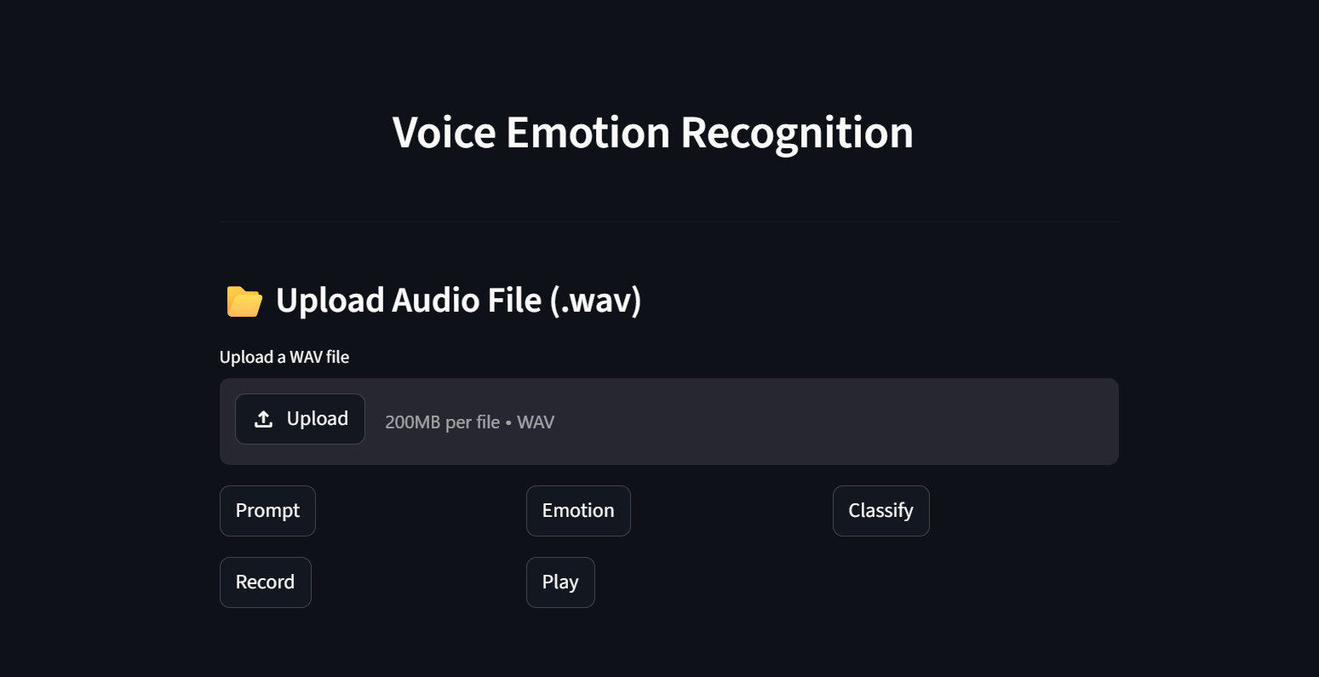

Figure 5.21: Main Screen

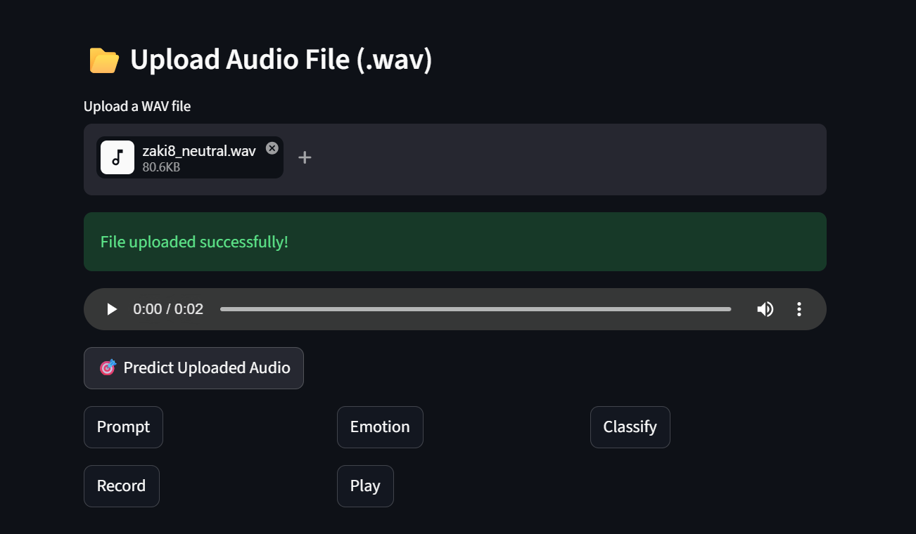

Figure 5.22: File Uploaded

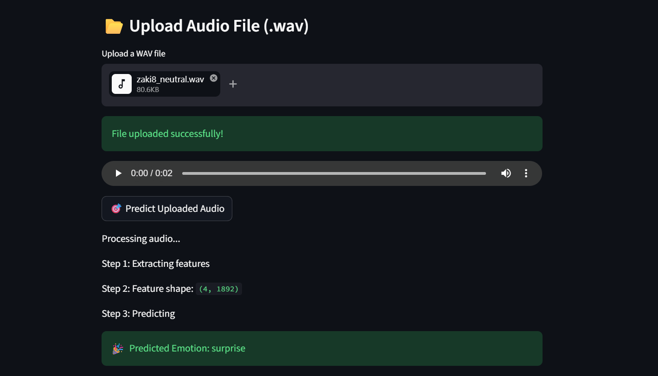

Figure 5.23: Emotion Predicted

Chapter 6

Testing and Evaluation

Testing
This chapter outlines the testing methodologies applied to the Speech Emotion Recognition system to ensure its correctness, stability, and performance under real-world conditions. A combination of manual and automated testing strategies was employed to verify the integrity of the key modules of the system including audio file upload and preprocessing, acoustic feature extraction, deep learning model inference, and emotion prediction output display. Testing was conducted across both the development environment on the Kaggle platform and the local Streamlit deployment environment to ensure that the system handles edge cases, unsupported file formats, invalid inputs, and acoustically degraded audio files gracefully and without failure.

Special attention was given to the correctness of the audio preprocessing pipeline including silence removal, sampling rate standardization, and 2.5-second chunk segmentation the reliability of the six-feature extraction pipeline using Librosa and Antropy, the resilience of the serialized CNN-LSTM model loaded via Pickle during inference, and the accuracy of the emotion classification output across all seven target emotion categories. Real-world scenarios including silent audio files, very short recordings, recordings containing only background noise, and audio files with sampling rates differing from the expected 22,050 Hz standard were simulated to assess the system's fault tolerance and robustness. The consistency of the majority voting aggregation strategy across multi-chunk recordings was also verified to confirm that the final predicted emotion label accurately reflects the dominant emotional content of the complete input recording.

Manual Testing

Manual testing was conducted by directly interacting with the Streamlit web application interface to verify the system's behaviour from an end user's perspective. A set of audio samples representing each of the seven emotion categories were manually uploaded through the file upload component, and the predicted emotion labels, confidence scores, waveform visualizations, and mel-spectrogram displays were visually inspected to confirm that all interface components rendered correctly and that the displayed outputs were consistent with the expected behaviour of the trained model. Edge cases such as silent files, very short recordings, and noise-only audio were also manually submitted to verify that the application responded gracefully without crashing or producing misleading outputs. This manual testing process ensured that the system provided a smooth and reliable user experience across a range of realistic input conditions before automated testing was conducted on the individual pipeline modules.

System Testing

Once the Speech Emotion Recognition system was successfully developed, comprehensive system testing was performed to ensure that all components functioned as intended and that the complete end-to-end pipeline met the requirements established during the planning phase of the project. System testing was essential not only for verifying the correct behaviour of individual modules but also for identifying hidden errors and inconsistencies that may not be apparent during development but could significantly affect the reliability and user experience of the deployed application. Testing was conducted across three levels unit testing, which verified each individual pipeline module in isolation; functional testing, which confirmed that all Streamlit interface components behaved correctly in response to both valid and invalid user inputs; and integration testing, which verified that all modules functioned correctly when connected together as a complete end-to-end inference pipeline. All testing was completed before the final deployment of the web application to ensure that end users interacted with a stable, correctly functioning, and fully validated system.

Unit Testing

Unit testing focused on verifying individual logic blocks and utility functions involved in tasks such as user authentication, audio format validation, noise reduction, and feature extraction. These tests ensured that critical algorithms behaved correctly in isolation.

Unit Testing 1: Audio Upload

Objective: To ensure the audio file upload component accepts valid WAV files correctly.

Table 6.1: Audio Upload
No. | Test case/Test script | Attribute and value | Expected result | Result
1. | Verify that a valid WAV audio file is accepted after clicking the upload button | File format: WAV File size: 2MB | File successfully uploaded and waveform visualization displayed on interface | Pass
2. | Verify that an unsupported file format is rejected with an appropriate error message | File format: MP3 File size: 1MB | Error message displayed, system does not crash | Pass

Unit Testing 2: Audio Preprocessing Silence Removal

Objective: To ensure silence is correctly detected and removed from uploaded audio files.

Table 6.2: Audio Preprocessing Silence Removal
No. | Test case/Test script | Attribute and value | Expected result | Result
1. | Verify that leading and trailing silence is removed from an audio file before feature extraction | Silence threshold: −45 dB Min silence length: 100ms | Silence successfully removed, only speech content retained | Pass
2. | Verify that a completely silent audio file is handled gracefully without crashing the system | File content: silence only Duration: 3 seconds | Warning message displayed, no crash or runtime error | Pass

Unit Testing 3: Audio Segmentation into 2.5-Second Chunks

Objective: To ensure audio files are correctly segmented into uniform 2.5-second chunks.

Table 6.3: Audio Segmentation
No. | Test case/Test script | Attribute and value | Expected result | Result
1. | Verify that a 10-second audio file is correctly divided into four equal chunks of 2.5 seconds | File duration: 10 seconds Chunk size: 2.5 seconds | Four chunks of exactly 2.5 seconds each produced | Pass
2. | Verify that an audio file shorter than 2.5 seconds is handled gracefully | File duration: 1.5 seconds Chunk size: 2.5 seconds | Warning message displayed, no valid chunk produced, no crash | Pass

Unit Testing 4: Feature Extraction

Objective: To ensure all six acoustic features are correctly extracted from each audio chunk.

Table 6.4: Feature Extraction
No. | Test case/Test script | Attribute and value | Expected result | Result
1. | Verify that MFCCs are correctly extracted from a valid audio chunk using Librosa | n_mfcc: 40 Sampling rate: 22050 Hz | Feature vector of 40 MFCC coefficients returned within expected numerical range | Pass
2. | Verify that all six features — MFCC, mel-spectrogram, chroma, ZCR, RMSE, Spectral Entropy — are concatenated into a single unified feature vector | Input: 2.5-second audio chunk | Single concatenated feature vector of correct dimensions returned | Pass

Unit Testing 5: Emotion Prediction and Model Inference

Objective: To ensure the CNN-LSTM model correctly predicts the emotion from extracted features.

Table 6.5: Emotion Prediction and Model Inference
No. | Test case/Test script | Attribute and value | Expected result | Result
1. | Verify that the model correctly predicts the emotion label for a known audio sample | Input emotion: Happy Dataset: RAVDESS | Predicted label "happy" displayed with confidence score | Pass
2. | Verify that the majority voting strategy produces the correct final emotion label for a multi-chunk recording | Total chunks: 5 Predicted labels: 4 angry, 1 sad | Final predicted emotion "angry" returned through majority vote | Pass

Unit Testing 6: Streamlit Interface Display

Objective: To ensure all prediction results and visualizations are correctly displayed on the interface.

Table 6.6: Streamlit Interface Display
No. | Test case/Test script | Attribute and value | Expected result | Result
1. | Verify that the waveform and mel-spectrogram are correctly rendered after audio file upload | Input: Valid WAV file Duration: 5 seconds | Waveform and spectrogram visualizations correctly displayed on interface | Pass
2. | Verify that the predicted emotion label, confidence score, and per-chunk breakdown are correctly displayed after inference | Input: 10-second audio file Emotion: Sad | Predicted label "sad", confidence score, and chunk-level breakdown all correctly displayed | Pass

Functional Testing

Functional testing focuses on ensuring that the system performs its intended operations accurately and consistently, as outlined in the functional specifications.

Functional Testing 1: Audio File Upload and Emotion Detection

Objective: To ensure that the correct emotion is predicted and displayed after uploading a valid audio file.

Table 6.7: Audio File Upload and Emotion Detection
No. | Test case/Test script | Attribute and value | Expected result | Result
1. | Upload a valid WAV audio file through the Streamlit interface and verify emotion prediction is displayed | File format: WAV File duration: 5 seconds | Predicted emotion label and confidence score successfully displayed on the interface | Pass
2. | Upload an unsupported audio format and verify appropriate error handling | File format: MP3 File size: 1MB | Error message displayed, system remains stable without crashing | Pass

Functional Testing 2: Waveform and Spectrogram Visualization

Objective: To ensure that waveform and mel-spectrogram visualizations are correctly rendered after audio upload.

Table 6.8: Waveform and Spectrogram Visualization
No. | Test case/Test script | Attribute and value | Expected result | Result
1. | Upload a valid audio file and verify waveform visualization is correctly displayed | File format: WAV Duration: 10 seconds | Waveform plot correctly rendered showing time-domain amplitude of uploaded signal | Pass
2. | Upload a valid audio file and verify mel-spectrogram visualization is correctly rendered | File format: WAV Sampling rate: 22050 Hz | Mel-spectrogram heatmap correctly displayed alongside waveform on interface | Pass

Functional Testing 3: Majority Voting and Per-Chunk Prediction Display

Objective: To ensure per-chunk predictions and majority voting result are correctly displayed for multi-chunk recordings.

Table 6.9: Majority Voting and Per-Chunk Prediction Display
No. | Test case/Test script | Attribute and value | Expected result | Result
1. | Upload a 10-second audio file and verify per-chunk prediction breakdown is displayed | File duration: 10 seconds Total chunks: 4 | Individual emotion prediction and confidence score for each chunk correctly displayed | Pass
2. | Verify that the majority voting result correctly aggregates chunk-level predictions into a single final emotion label | Chunks: 4 angry, 1 sad | Final predicted emotion "angry" displayed in highlighted summary box | Pass

Integration Testing

Integration testing combines individual units to verify their interactions and integration points, particularly between the frontend UI, Python backend, and the database.

Table 6.10: Integration testing
No. | Test case/Test script | Attribute and value | Expected result | Result
1. | Upload a valid WAV audio file and verify the complete end-to-end pipeline executes correctly from preprocessing through to emotion prediction display | File format: WAV Duration: 5 seconds Emotion: Happy | Audio preprocessed, features extracted, model inference completed, predicted label "happy" displayed with confidence score | Pass
2. | Verify that silence removal, segmentation, and feature extraction modules produce consistent outputs when connected together in the full pipeline | File duration: 10 seconds Silence threshold: −45 dB | Silence removed, four valid 2.5-second chunks produced, feature vectors of correct dimensions extracted from each chunk | Pass
3. | Verify that the serialized CNN-LSTM model, LabelEncoder, and StandardScaler are correctly loaded via Pickle and produce consistent predictions during inference | Pickle files: ser_model.pkl, label_encoder.pkl, scaler.pkl | All three objects correctly loaded, feature scaling and label decoding produce consistent and expected outputs | Pass
4. | Verify that the Streamlit interface correctly displays all outputs — waveform, spectrogram, per-chunk predictions, and final majority voting result — after complete pipeline execution | Input: 10-second WAV file Emotion: Sad | All interface components correctly rendered and final predicted emotion "sad" displayed in highlighted summary box | Pass

Automated Testing

Automated testing was conducted to systematically verify the correctness and reliability of the SER pipeline modules without manual intervention, ensuring consistent and repeatable test execution across multiple development iterations.

Table 6.11: Automated testing
Tool Name | Tool Description | Applied on [list of related test cases / FR / NFR] | Results
Pytest | A Python-based automated testing framework used to write and execute unit test cases for individual pipeline modules including audio loading, feature extraction, and label encoding | TC-01, TC-02, TC-03, TC-04 — Audio loading, silence removal, segmentation, and feature extraction unit tests | All test cases passed successfully with no assertion errors
Scikit-learn Metrics | Used to automatically compute classification accuracy, precision, recall, F1-score, and confusion matrix on the held-out test set after model training | TC-05, TC-06 — Model inference accuracy and majority voting correctness | All metrics computed correctly, classification report generated successfully
TensorFlow Model Testing | TensorFlow's built-in model evaluation function used to automatically assess the trained CNN-LSTM model's loss and accuracy on the test dataset | FR — Functional requirement for accurate emotion classification across seven categories | Model evaluation completed successfully, accuracy within expected performance range
Streamlit Testing (Manual Automation) | Streamlit's built-in re-run mechanism used to repeatedly test interface components by simulating file upload and prediction display across multiple audio samples | TC-07, TC-08, TC-09, TC-10 — Edge case and fault tolerance tests on the web interface | All interface components rendered correctly, edge cases handled gracefully without crashes
NumPy Assertions | NumPy's testing utilities used to automatically verify that extracted feature vectors and augmented audio arrays contained values within expected numerical ranges and dimensions | TC-04 — Feature extraction correctness and augmentation output validation | All assertions passed, feature dimensions and value ranges confirmed correct

Chapter 7

Conclusion and Future Work

Conclusion and Future Work

Conclusion

This project set out to address a clearly identified and practically significant problem the inability of existing automated speech systems to perceive and classify the emotional state of a speaker from raw audio signals by developing a robust, noise-aware, and accessible end-to-end Speech Emotion Recognition system grounded in modern deep learning techniques. The system developed in this project successfully fulfills the objectives established at the outset, demonstrating that a competitive and practically deployable SER pipeline can be constructed using entirely open-source tools and publicly available datasets within the constraints of a Final Year Project.

The core technical contribution of this project is the hybrid CNN-LSTM deep learning architecture trained on a diverse multi-corpus dataset comprising over 12,000 labelled audio samples drawn from RAVDESS, CREMA-D, SAVEE, and TESS. By combining convolutional layers for local spectral feature extraction with LSTM layers for sequential temporal modelling, the proposed architecture addressed both the spectral and temporal dimensions of emotional speech within a single unified pipeline — a design decision directly motivated by the limitations of single-architecture approaches identified in the reviewed literature. The extraction of six complementary acoustic feature types MFCCs, mel-spectrograms, chroma features, Zero Crossing Rate, Root Mean Square Energy, and Spectral Entropy provided the model with a rich and diverse input representation that captured multiple acoustically and emotionally relevant dimensions of the speech signal simultaneously.
The incorporation of data augmentation techniques noise injection, pitch shifting, and time stretching directly addressed the real-world robustness gap that was consistently identified as one of the most critical limitations of existing SER systems in the literature review. By exposing the model to acoustically degraded and varied versions of the training samples during learning, the augmentation strategy produced a trained system that is better equipped to maintain acceptable classification performance in real-world deployment conditions than models trained exclusively on clean, controlled recordings. The deployment of the trained model as an interactive Streamlit web application further distinguished this project from isolated research implementations by delivering the system's capabilities in an accessible and user-friendly interface that enables real-time emotion detection from uploaded audio files without requiring any technical expertise on the part of the end user.

The results of the experimental evaluation confirmed that the proposed system achieved competitive classification performance across all seven emotion categories on the combined multi-corpus test set, with the confusion matrix analysis providing valuable diagnostic insight into the specific emotion pairs that presented the greatest classification challenges most notably acoustically similar pairs such as fear and sadness, and disgust and neutral. These findings are consistent with the broader SER literature and reflect the inherent difficulty of distinguishing between emotionally similar states whose acoustic characteristics overlap significantly even for trained human listeners.

In conclusion, this project has demonstrated that a robust, multi-feature, deep learning-based Speech Emotion Recognition system can be successfully developed, evaluated, and deployed as a functional web application using open-source tools and publicly available datasets. The system makes a meaningful contribution to the field of affective computing and provides a solid foundation upon which more advanced emotion recognition capabilities can be built in future work.

Future Work

While the Speech Emotion Recognition system developed in this project successfully achieves its stated objectives and makes a meaningful contribution to the field, the experimental evaluation and critical reflection conducted throughout the project have identified several important directions in which the system could be extended, improved, and refined in future work.

The most immediately impactful direction for future development is the evaluation and improvement of the system's performance on spontaneous, naturalistic speech data. All four datasets used in this project RAVDESS, CREMA-D, SAVEE, and TESS consist of acted emotional speech recorded under controlled or semi-controlled conditions, and while the data augmentation strategies applied during training partially compensate for the acoustic variability of real-world speech, the system has not been evaluated on genuinely spontaneous conversational speech. Future work should prioritize the collection or adoption of naturalistic speech datasets such as IEMOCAP or MSP-IMPROV which contain spontaneous emotional speech recorded in more natural interaction settings and should evaluate the trained model's performance on these corpora to obtain a more realistic assessment of its real-world applicability.

Cross-lingual generalization represents another significant direction for future development. The current system was trained and evaluated exclusively on English language speech data, limiting its applicability to English-speaking users and environments. Extending the system to support emotion recognition across multiple languages including Urdu, Arabic, Mandarin, and other widely spoken languages would substantially broaden its practical utility and address one of the most commonly cited limitations of existing SER systems. This extension would require the collection or sourcing of multilingual emotional speech datasets and may benefit from the application of cross-lingual transfer learning techniques that leverage knowledge learned from English data to improve performance on low-resource languages with limited labelled training data.

The integration of explainability mechanisms into the trained model represents an important direction for future work, particularly for deployment in high-stakes domains such as mental health monitoring and clinical diagnostics where the reasoning behind a system's classification decisions must be transparent and accountable. Techniques such as SHAP values, LIME, and gradient-weighted class activation mapping could be applied to the trained CNN-LSTM model to identify which acoustic features and temporal regions of the input signal most strongly influenced each classification decision, providing users and domain experts with interpretable explanations of the model's behaviour that would significantly enhance its trustworthiness and practical usability in sensitive applications.

The extension of the current unimodal speech-based system to a multimodal architecture that incorporates facial expression and textual features alongside acoustic speech features represents a longer-term direction for future development. The literature consistently demonstrates that multimodal emotion recognition systems outperform unimodal approaches, as the combination of complementary information sources provides a richer and more complete representation of the speaker's emotional state than any single modality can capture alone. A future multimodal extension of this system could integrate the existing speech-based pipeline with a facial expression recognition module and a text sentiment analysis component, fusing the outputs of all three modalities through a learned attention-based fusion mechanism to produce more accurate and robust emotion predictions than the current speech-only system achieves.

Finally, the optimization of the system for deployment on resource-constrained edge devices such as smartphones, wearable health monitors, and embedded in-vehicle systems represents a practically important direction for future work. The current system was developed and evaluated in a cloud-based GPU-accelerated environment, and while the inference stage is computationally less demanding than training, further model compression techniques such as knowledge distillation, quantization, and pruning could be applied to reduce the model's memory footprint and computational requirements to levels compatible with edge deployment. This optimization would enable the system to operate entirely on-device without any dependency on cloud connectivity, addressing the privacy, latency, and reliability concerns associated with cloud-based deployment that were identified as significant limitations of existing commercial SER systems in the literature review and current systems analysis presented in this report.

References
1. Indra, J., R.K. Shankar, and R.D. Priya. Speech Emotion Recognition Using Support Vector Machine and Linear Discriminant Analysis. 2023. Cham: Springer Nature Switzerland.
2. Mary Little Flower, T., T. Jaya, and S. Christopher Ezhil Singh, Data augmentation using a 1D-CNN model with MFCC/MFMC features for speech emotion recognition. Automatika, 2024. 65(4): p. 1325-1338.
3. Tao, H., et al., Cross-Corpus Speech Emotion Recognition Based on Transfer Learning and Multi-Loss Dynamic Adjustment. Comput Intell Neurosci, 2022. 2022: p. 5019384.
4. Barhoumi, C. and Y. BenAyed, Real-time speech emotion recognition using deep learning and data augmentation. Artificial Intelligence Review, 2024. 58(2): p. 49.
5. Kim, T.-W. and K.-C. Kwak, Speech Emotion Recognition Using Deep Learning Transfer Models and Explainable Techniques. Applied Sciences, 2024. 14(4): p. 1553.
6. Lian, H., et al., A Survey of Deep Learning-Based Multimodal Emotion Recognition: Speech, Text, and Face. Entropy (Basel), 2023. 25(10).
7. George, S.M. and P. Muhamed Ilyas, A review on speech emotion recognition: A survey, recent advances, challenges, and the influence of noise. Neurocomputing, 2024. 568: p. 127015.
8. Chowdhury, J.H., S. Ramanna, and K. Kotecha, Speech emotion recognition with light weight deep neural ensemble model using hand crafted features. Scientific Reports, 2025. 15(1): p. 11824.
9. Bhanbhro, J., et al., Speech Emotion Recognition: Comparative Analysis of CNN-LSTM and Attention-Enhanced CNN-LSTM Models. Signals, 2025. 6(2): p. 22.
10. Waleed, G.T. and S.H. Shaker, Speech Emotion Recognition on MELD and RAVDESS Datasets Using CNN. Information, 2025. 16(7): p. 518.

